HOLWELL NEIGHBOURHOOD PLAN

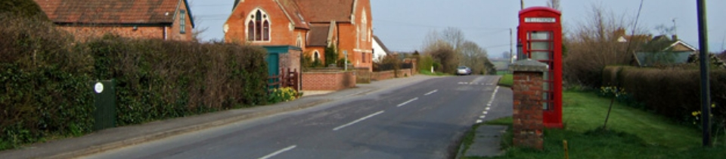

PRODUCED BY HOLWELL NEIGHBOURHOOD PLAN WORKING GROUP
FOR HOWELL PARISH COUNCIL

Executive Summary

Holwell Parish Council was keen to investigate Neighbourhood Planning and took up this opportunity early in the life of the idea. The West Dorset Local Plan was not adopted until December 2015 but while that process was continuing, several planning matters arose that suggested having more control over building in our Parish could only be a good thing.

The Policies in the Local Plan rightly give preference to placing larger developments nearer existing, larger settlements where the infrastructure ensures the sustainability of the development. For villages over 200 heads which have no recognised settlement boundary in the form of a Defined Development Boundary (DDB), the Local Plan assumed there would be no development other than Rural Exception Sites (RES). Holwell qualifies in this category.

Whilst buildings such as the conversion of existing farm buildings under the RES rules may be seen as acceptable to residents, a proposal to build a mini-estate of 14 new houses ensured that residents became active in protest. The style of development was at odds with the general style of Holwell properties and, with few people with a local connection on the Housing list and an unsustainable village – no shop, school, pub, limited bus route etc - it was hard to see how the development could be deemed to be sustainable. However, the Planning Inspector did not agree and so the Crouch Lane houses are due to be built by Stonewater as 100% affordable which also means the Parish Council does not qualify for Community Infrastructure Levy funds.

It was clear that residents wanted a plan that meant they could decide what was developed in Holwell in the future. Following the Crouch Lane appeal decision, the Parish Council held a public meeting asking if people wanted to continue with the Neighbourhood Plan; on a show of hands from the 60 or so residents that attended, it was agreed to go ahead.

Holwell appears to be a village with polarised opinions on most matters and the number of houses to be built during the life of this Plan was no exception. Some people wanted no further development other than what is allowed by the Local Plan and others were keen to see up to 10 houses built so we used a mean average of the two extremes to reach a decisive figure.

We want a long term future for Holwell, its residents and businesses and lay out in this plan how we want Holwell to develop. We have a proposal for the number of houses we should be developing and the Village Hall Committee are seeking to rejuvenate one of our key community assets, the Village Hall, to support residents for years to come. We have lots of evidence relating to the environment around Holwell that we wish to continue to enjoy and hope this Plan meets our vision and aims.

Holwell is a great place to live with a wonderful countryside which is greatly treasured by walkers, horse riders, wildlife enthusiasts, star gazers and those that just want a quiet life This plan aims to protect what already exists here that makes Holwell unique whether that is buildings, views, community assets or wildlife whilst encouraging development that the Parish Council and residents have agreed is appropriate and meets our needs

Contents
The Neighbourhood Plan 4
Introduction to the Neighbourhood Plan 4
The Local Plan 4
Process of Producing a Neighbourhood Plan 5
About Our Area – Its Character And Heritage 7
DEVELOPMENT – HOUSING 8
Strategic Objective 8
Housing Development & Growth Projections 8
Site Options 9
Housing Policies 10
Policy H1: Amount and Location of New Housing (SUS1) 10
Policy H2 : Affordable Housing – Exception Sites (HOUS 1 and HOUS 2) 10
DEVELOPMENT - EMPLOYMENT & BUSINESS 11
Strategic Objective & Policies 11
Employment & Business in Holwell 11
Employment & Business Policy 11
Policy EB1: Locations for Employment and Business 11
COMMUNITY FACILITIES, INFRASTRUCTURE AND QUALITY OF LIFe 12
Strategic Objective & Policies 12
Current Facilities 12
Community Facilities 12
Village Hall 12
Church 13
Nursery/School 14
Public Rights of Way 14
Community Policy 14
Policy C1: Important Community Facilities 14
TRANSPORT, INFRASTRUCTURE AND COMMUNICATION 15
Road infrastructure and safety 15
Transport & Infrastructure Policies 15
LANDSCAPE & ENVIRONMENT and design 16
Strategic Objective & Policies 16
Landscape and Views 16
Landscape Policy 17
Policy E1: Locally Important Views 17
Important Green Spaces, Wildlife and Landscape Features 17
Green Spaces & Wildlife Policy 18
Policy E2: Locally Important Green Spaces, Wildlife and Landscape Features 18
Buildings and Structures of Local Importance 18
Buildings & Structures Policy 19
Policy E3 : Buildings and Structures of Local Importance 19
Rivers, Waterways and Flooding 19
Design 19
Design Policy 20
Policy E4: Design 20
Materials Palettes 24
Details Palettes 24
Windows/Chimneys/Additional Features 25
Masonry Detailing/Porches 26
MONITORING AND REVIEW 28

The Neighbourhood Plan

Introduction to the Neighbourhood Plan
As the Locality Act came into force in 2011, Holwell Parish Council decided to prepare a Neighbourhood Plan for the parish. A Working Group was set up consisting of Parish Councillors and other parishioners who were interested in taking part in this project. They agreed that producing a Neighbourhood Plan would allow us, as a community, to influence what happens in our Parish in the future. Neighbourhood plans are used to decide the future of the places where residents live and work and include choosing places to build new homes and other types of buildings. They can say what these new buildings should look like and where certain land might be used for different purposes, such as recreation areas.
When approved, our Neighbourhood Plan becomes part of the Local Development Plan and its policies will work alongside the policies in the Local Plan in our parish. Although it has to be in line with the Local Plan’s strategy for the area, a Neighbourhood Plan can make significant changes to the approach taken in the Local Plan. In our plan we have:
- Identified areas where development can happen around the main settlement.
- Identified a location for a rural exception site for affordable housing, if required.
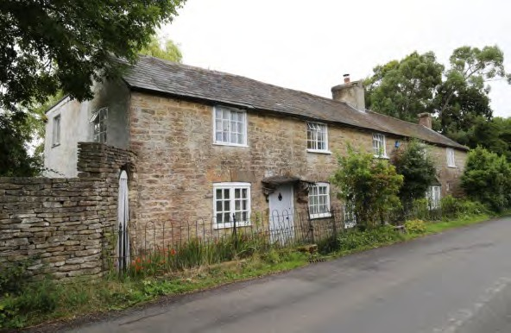
- Provided greater certainty over what is special about our area and how those features should be considered in allowing new development.
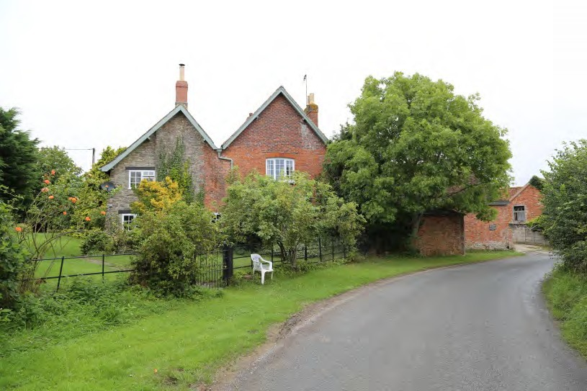

The Local Plan
The Local plan is the West Dorset, Weymouth and Portland Local Plan 2011-2031; it was adopted in October 2015. The Local Plan is valid until 2031 and is currently being reviewed. It states that although a lot of demand for new housing exists in the rural areas such as Holwell, there are problems associated with providing more housing in places that have few jobs or facilities. The resulting dependency on cars inevitably increases carbon emissions and disadvantages those who don’t have a car (usually the more vulnerable groups in our society), which is why it makes sense to try to focus development on the towns. As each village will be different in terms of its needs, opportunities and constraints, the Local Plan allows a more enabling approach for rural communities – working with those that want to see development take place so they can identify suitable sites to meet their local needs. Using neighbourhood development plans and other planning tools, communities can allocate sites, introduce or extend a development boundary, or develop a criteria-based policy to allow development to take place, where they consider this is the right approach for them.
Policy SUS2 of the Local Plan, DISTRIBUTION OF DEVELOPMENT, states that development will be distributed according to a settlement hierarchy. Away from settlements, development will be strictly controlled, having particular regard to the need for the protection of the countryside and environmental constraints. Holwell has no defined settlement boundary, and new sites within or on the edge of the settlement are therefore unlikely to be approved for open market housing without a Neighbourhood Plan. New employment premises, community facilities, and affordable housing would still be considered favourably, subject to certain criteria being met.

Process of Producing a Neighbourhood Plan
Following the launch by the Parish Council in 2011 the Working Group initially prepared some scoping studies around Housing, Employment and Business, Roads and Transport, Environment and Community. From 22nd October 2015, a new Chair took over and initially focused on ensuring that there was a clear Vision and Aims for the Working Group and Plan. The Group also agreed a set of Terms of Reference and a set of Principles in Public Life and all documents were reviewed and published in early 2016.
The Working Group prepared a Vision and set of Strategic Objectives, published in January 2016, to guide their work on the Neighbourhood Plan. These are shown below:

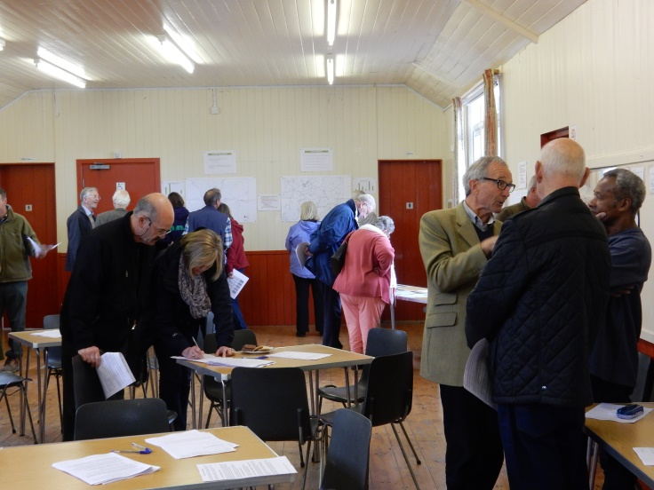
In April 2016, the Group held initial Village Consultation sessions for the residents asking them to define what they felt were the key issues that a Plan should address. The results of this Scoping consultation were used to create a more focused household questionnaire which was hand delivered to and collected from every household in October and November 2016. Further Village Consultation sessions were then held in December 2016 so residents could see what the responses said. All this information was also posted on the Neighbourhood Plan section of the Parish Council web site to ensure the widest coverage. For both of these consultation processes, the level of involvement was good Details of the responses are available at Appendices A and B.
In parallel, a formal notice was issued, asking landowners whether they had sites that they wished to be considered as part of the process. The Group prepared a set of Site Assessment criteria and a set of Assessment Scoring criteria so that each site could be reviewed and scored. Initially 19 sites were put forward with a further 5 being submitted during the assessment period, giving a total of 24 sites for consideration. The site assessments were undertaken using the Site Assessment criteria and Scoring methods at a meeting in April 2017 and at two meetings in May 2017. These resulted in three groups of sites that either met the criteria well or met the criteria in most areas, or did not meet the criteria. These proposals were then displayed at open meetings in July, August and September 2017 so that residents could make their own decisions on the information displayed and give their opinion and comments on which sites they would prefer to see put into the Plan document for development.
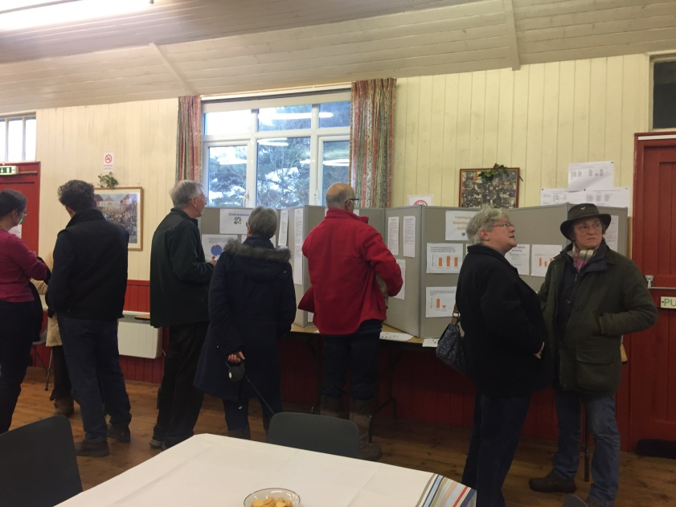
Help was provided by Oliver Rendle, Environmental Assessment Officer at the Dorset Combined Councils who produced a Screening Assessment to determine whether or not the Holwell Neighbourhood Plan required a Strategic Environmental Assessment (SEA) through a process known as SEA screening. The report provided an account of the SEA screening exercise for the Holwell Neighbourhood Plan and, following the consultation, the SEA screening report concluded that the Holwell SEA is unlikely to result in significant environmental impacts and therefore a full SEA was not required in this instance. The Screening Report is attached at Appendix C.
The Working Group undertook evidence collection through a range of means and by a number of the Working Group. Examples include speaking to local business people and key stakeholders such as the Three Valleys Benefice Team Vicar, local farmers etc. A grant was secured from Locality to commission a Heritage and Character report from AECOM to help provide an external view of what to value about Holwell during this Neighbourhood Plan process. Various members of the Working Group provided significant input on the environment, on places or views of key interest and also on the impact of potential flooding to the parish. A report on Planning Design Guidelines was also produced, again produced by AECOM, to propose sensitive treatment of any proposed development such that it retains and enhances the look and feel of Holwell’s buildings and environment. These reports are included as Appendices D and E.
The Working Group started drafting the Plan documents using the evidence collected during the two consultation sessions, from nationally available statistical data, from reference documents, from meetings with stakeholders and the reports supplied through grant funding and with the help of Jo Witherden, Dorset Planning Consultant to help draft policies that reflect the community’s views.
The Working Group had agreed the proposed method to be used to analyse the responses received so that the outcome of the number of sites selected was in line with all those who had responded. The responses to the Site Options Consultation were reviewed by the Working Group at a meeting on 18th January 2018 giving the detailed calculations that had been made to ensure that we put forward sites in line with residents’ resposnes received from residents. The final number and detail of sites were then confirmed with the group. They also reviewed all the comments made and agreed actions. It was agreed that we would hold consultation meetings with residents to allow them to provide feedback on the outcomes and also to review a draft of the Plan prior to any formal consultation process.
This draft Plan has been prepared as a result of this research and consultation.

About Our Area – Its Character And Heritage
370 PEOPLE
10 square kilometres
very RURAL PARISH with few facilities, the nearest town is Sherborne (10km away)
traditional, pastoral CLAY VALE landscape with mature oaks, hedgerows and streams
23 LISTED buildings and structures, plus many other features of local interest, including an extensive network of ancient TRACKS and FOOTPATHS
See Facts and Figures document for more detail
The Parish of Holwell (the designated Neighbourhood Plan area – see Figure 1) is located in West Dorset and has a population of approximately 370 residents (DCC, Dorset Data Book, and Census 2011). It covers approximately 10 square kilometres (or 2,400 acres) of gently undulating, mainly agricultural land. The main settlement of Holwell is focused around Fosters Hill, Crouch Hill, Pleck and Gunville, and the wider area comprises generally undeveloped, small clustered hamlets (including Holwell Borough; Buckshaw; The Manor and Sandhills; Westrow; Hill Street; Packers Hill and Piccadilly; and Woodbridge) and individual farmsteads. Although there are now significantly fewer smallholders and farms than in the 1900s, Holwell’s 10 working farms remain largely non-intensive, supporting a thriving wildlife community and distinctly rural environment which is much appreciated by its residents.
The surrounding landscape comprises chalk escarpments and limestone hills, as the parish borders the rolling hills and valleys of the Blackmore Vale, with views to Bulbarrow and the Dungeon Hills. The undulating land is largely Oxford Clay, drained by numerous small streams running north to join Caundle Brook, with an area of sandy loan at Sandhills.
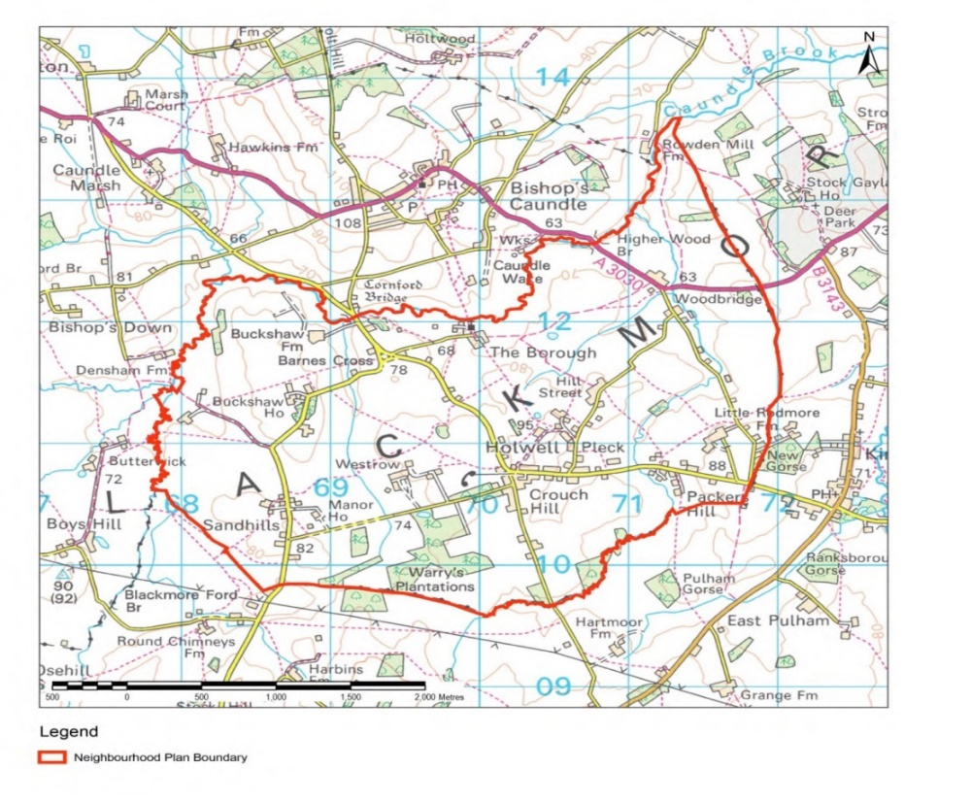
Outside of the parish the nearest settlements include Bishops Caundle to the north, Kings Stag to the east and Pulham to the south; these small settlements are set apart by large spans of agricultural land and patches of woodland and contribute to the remote, rural character of the area. Larger settlements are a further distance from Holwell including Sherborne 10km to the north west and Dorchester 25km to the south.
Figure 1: Parish of Holwell

DEVELOPMENT – HOUSING

Strategic Objective
To meet diverse local housing needs taking into account changing demographics and social requirements

Housing Development & Growth Projections
The settlement of Holwell is one of a group of 200+ populations identified in the Local Plan. Holwell is deemed not to have sufficient facilities to be considered a sustainable settlement where development should be focused, but as a settlement with no defined development boundary it may have some limited growth to meet its local needs. Away from the settlement, it is considered to be countryside where development will be strictly controlled, having particular regard to the need for the protection of the countryside and environmental constraints.
Although there have been different rates of growth historically, at the start of the 21st century (in the 15 years from 2000 - 2015) there was a very low rate of development due to the restrictive planning policies in place. No new homes were built between 2006 and 2014.
In 2012, an application for an agricultural dwelling was approved, and in 2014 permitted development rights were introduced allowing barn conversions, providing a more flexible approach to the Local Plan restrictions on the re-use of rural buildings. In 2016, with the absence of a 5 year housing land supply across West Dorset and perceived need for affordable housing for Holwell and the surrounding parishes, a major development of 14 new affordable dwellings was considered, and although initially refused, it was allowed on appeal in early 2017. Despite the likely reliance on private cars for most trips, the proposed development was seen as having real benefits in sustaining the local services and facilities in Holwell and the nearby settlements of Bishops Caundle and Kings Stag. Following a prolonged period of little or no development, the pace of development within the parish will now accelerate significantly over the next few years.
Eleven households responded to the Neighbourhood Plan Questionnaire in October 2016 stating that someone in their household would be requiring accommodation, the majority of whom were children who would be wanting a place of their own on reaching adulthood. Of these, 3 would be looking to buy a property, 3 looking for social (affordable) housing, 2 looking to self-build, 1 looking for a starter home and 2 did not specify. The main need was for 2 bedroom homes. A clear consensus view of the community was that any new building should be restricted to small-scale developments on infill sites, with no development on back land. The general preference expressed was for small family homes, homes for single people and starter homes, followed by affordable housing types.
As of January 2018, there were 2 households on West Dorset District Council’s Affordable Housing Register with a ‘local connection’ to the Neighbourhood Plan area.
The Local Plan does not set specific housing need targets for areas such as Holwell. If the development strategy had simply been to distribute the projected housing need across the area, on a pro-rata basis, the potential ‘target’ for the amount of development within Holwell parish for the period 2016 to 2031 would have been about 26 dwellings. The 14 dwellings at Crouch Lane and 6 others with planning consent still to be built should be included within this figure. Given the Local Plan strategy, this could be viewed as an ‘upper’ level to sustainable growth, and would equate to a 15% increase in the number of homes between 2011 and 2031.

Site Options
The Working Group’s ‘Call for Sites’ in 2016 elicited 24 sites for consideration as appropriate for residential (or other) development. This included one site, owned by Magna Housing Association, to be considered as a rural exception site for affordable housing.

Refining site options for consultation
The criteria below were developed using information from public meetings and through the village questionnaire results and were used by the Neighbourhood Plan Working Group to identify those sites likely to be able to contribute positively towards sustainable development.
- Ensure development is appropriate to the area within which it is placed
(is the site well related to the built-up area of the village and not notably prominent in the wider landscape?)
- Ensure development is complementary to neighbouring properties
(would housing development at this site fit in with neighbouring development?)
- Ensure development reinforces the settlement area within which it is placed
(would housing development at this site enhance the surroundings?)
- Retain green spaces and key views
(would the site avoid the loss of an important view or local landscape feature?)
- Minimise the impact of traffic flow
(would the site avoid causing or adding to existing traffic problems, and could it provide solutions to reduce existing problems?)
- Preserve the long term future of community assets (Church, village hall and nursery school)
(would the development of the site support the improvement or continued use of key community facilities?)
- Retain the "village" feel and open nature of Holwell
(Could the site be developed to contribute positively to the character of the village and avoid overlooking/backfill affecting properties?)

All sites were first assessed for housing based on one house or bungalow per site, with an assumption that hedgerows and trees would be retained where possible. These assessments were then tested through an options consultation stage for all residents of Holwell. Properties were displayed as ‘green’ sites being those that scored highest against the selection criteria, or ‘amber’ sites being those scoring less well but still broadly positive or neutral, with “red” sites deemed the least suitable with possible adverse impacts. Open meetings were held so that residents could review information collated on each site and the ratings given to the site against the defined criteria. Residents were asked to complete a Site Options questionnaire that asked them to rate the sites themselves and give their views on their acceptability.
A summary of the submitted sites and main issues identified is set out in Appendix F.
Given the housing development and growth projections above, further consultation with local residents asked whether any further growth would be welcomed. Their responses showed that limited growth of about 3 new dwellings would be supported in addition to that which would come forward through existing policies (ie conversions, affordable housing and rural workers dwellings). This was considered a reasonable level of growth by the Local Planning Authority, and would mean that Holwell was certainly providing its ‘fair share’ of housing.

Housing Policies
The following policy allocates the preferred sites for housing development, on the basis that each site is suitable for 1 dwelling, and accords with the other policies in this Neighbourhood Plan, particularly regarding design.

Policy H1: Amount and Location of New Housing (SUS1)

Provision is made for up to three (3) new build, open market dwellings to be developed in Holwell during the Plan period (to 2031), through allowing one dwelling on each of the identified sites allocated in this Neighbourhood Plan and shown on the map at Appendix G.

This development will supplement the Local Plan policies that support affordable housing, rural workers dwellings and affordable housing rural exception sites.

The sites selected for new build, open market housing are as follows:
- Site between Roseacre & Newhaven, Fosters Hill.
- Plot adjacent to The Rectory, Pulham Road.
- Westbourne.

The following site would be selected if one of the three above was found to be unsuitable at some future stage:
- Site adjacent to Gunville House.

Although the Magna Housing Association site was not selected within the top three sites for housing, local residents indicated that they would support its use for affordable housing should a need arise. At the time of writing this plan, the likely need for affordable housing was more than accommodated for on the Crouch Lane site adjoining the Nursery School. However this may not be sufficient for the whole plan period, and it is important that any identified need arising from a local community can be met. As such, the Magna site has been included in this plan. If developed, future occupancy will also be prioritised for people with a local connection (for example those living or working in the local area, or with close family in the area).

Policy H2 : Affordable Housing – Exception Sites (HOUS 1 and HOUS 2)

The site to the rear of 7 and 8 The Plot (as shown on map at Appendix H) is identified as the preferred location for a rural exception site for affordable housing for local people, should the need arise within the plan period.

The site would be developed for 100% affordable housing, in accordance with the local plan policy for rural exception sites. A legal agreement will be sought with the developers and providers of affordable housing to ensure that it remains affordable in perpetuity and allocations are prioritised to people with a local connection to the parish of Holwell.

DEVELOPMENT - EMPLOYMENT & BUSINESS

Strategic Objective & Policies
To support existing business, encourage new enterprises and facilities which will enhance commercial effectiveness and employment opportunities

Employment & Business in Holwell
The main occupations of Holwell residents are centred on agriculture or on professional services, with a significant retired population. Of the 10 farms (and smallholdings) operating within Holwell, the largest are dairy farms, notably at Holwell Hill Farm on Pulham Road, at Lower Buckshaw Farm and at Woodbridge Farm. Sandhills Farm also has a dairy operation based in nearby Leigh and grows grass on its Holwell acreage as feed. There are also a number of beef farmers, the largest of which are on Pulham Road, and at Cornford Farm, although the latter’s main grazing land is at Caundle Marsh. Beef cattle are also farmed on smallholdings within the parish. Holwell’s main sheep farm is the Sherborne flock at Hill Street Farm, Stony Lane. A combination of sheep and beef is also farmed on a smaller scale at Holwell Manor and from Proctors Cottage, where heifers are reared on. In addition to farming their own land many farms rent fields from other landowners within the parish as well as acquiring additional land in the parish or elsewhere to provide adequate grazing for existing cattle numbers or to enable expansion. This can occasionally lead to cattle being driven along Holwell’s roads from one grazing area to another. Farm traffic itself can be heavy, particularly at harvest time with tractors collecting and delivering grass, in addition to feed deliveries and milk collection. Most of these farms are family owned and run businesses, only employing non-family personnel when necessary on a part-time or seasonal basis from within the larger local community. There is some local employment in farm based industries such as Honeybuns gluten free cakes and Dorset Blue Vinney cheese and related products.

Local employment opportunities are limited, and people looking for work will either work from home or commute to the nearby towns or further afield. Local residents have indicated that they would support small-scale businesses looking to set up in the parish. However this needs to be balanced against the impact of such development on the environment, local road network and the amenity of nearby residents.

There are no hotels or bed and breakfast accommodation in Holwell although these are available in nearby towns or villages with the most likely destination to stay being Sherborne. However, there is provision for glamping holidays at Honeybuns and for Yurt Holidays at Stock Gaylard which lies just outside the parish. These are relatively new businesses offering tourists the option to stay in Holwell through organisations with a strong rural sustainability focus which fits well with the local culture. There is also a retreat operating from Middle Piccadilly.

The Local Plan does provide for a range of opportunities within rural areas, with new general employment sites / workshops and built tourist accommodation either re-using existing premises or located on sites within or adjoining settlements. In Holwell what is or is not part of the settlement has not been defined through the Local Plan, and therefore the areas to which these policies might apply is unclear. Proximity to what might be considered the main area of settlement around Fosters Hill, would potentially preclude otherwise acceptable sites which, although potentially less accessible on foot, would still provide valuable employment opportunities more locally than travelling outside the area. However it is important that any such development does not detract from the rural character of the countryside, or cause nuisance to neighbours.

Employment & Business Policy

Policy EB1: Locations for Employment and Business
New employment premises and built tourist accommodation should either:
- be well-related to existing buildings and the highway network, or
- be part of a farm diversification scheme, or
- re-use an existing building
and should avoid adverse social or environmental impacts that would clearly outweigh the potential economic benefits, through:
- having good road access, avoiding routes through residential or other sensitive areas where significant traffic movements would be detrimental to the living conditions of residents or cause harm to designated heritage or other environmental assets,
- not generating noise, pollution or other effects which would cause harm to the living conditions of nearby residents or harm the enjoyment of public areas,
- ensuring the scale, massing, design of new premises is not incongruous in the landscape, taking into account mitigation provided by landscaping.

COMMUNITY FACILITIES, INFRASTRUCTURE AND QUALITY OF LIFe

Strategic Objective & Policies
To preserve the long term future of the area by retaining and if possible enhancing local services, infrastructure and facilities, promoting a safe and healthy community.

Current Facilities

Community Facilities
There are three community facilities in Holwell - the village hall, the parish church and the nursery school. Despite the limited venues, the parish has a range of regular activities, which include annual events such as the church fete and harvest supper, and more frequent events such as bi-annual ‘Fish & Chip’ quizzes, Parish Council and Village Hall meetings and club activities. With the exception of the Youth club, all meet at the Village Hall. The Youth Club only makes use of the Hall on a monthly basis for activities which cannot be enjoyed at its usual venue, the Granary, which is next to the new Rectory. The village lacks open spaces that could be used by its residents for events and activities, and no playing fields are available for Holwell’s children.
Holwell’s last public house, The Fox Inn, burnt down in 1963, and the garage and village shop closed in 1988 and 1995 respectively. Having been reopened in 1982, and despite having 38 children attending in 1987, the village primary school closed in 1990 (the building is now used by Holwell Nursery).
In the consultation in April 2016, where residents were encouraged to say what they wanted to see in Holwell, there was strong feedback wishing for new facilities such as a community shop, pub, sports facilities, coffee shop, countered by a strong sense that these had been tried before and found unviable. The shop/bar or social club was proposed as an activity that the village hall could incorporate. Also high on the list was a recreation ground or children’s play area that could be used for village functions or sports as there is currently no facility for this in Holwell. In the October 2016 Household Questionnaire, 70% of respondents asked for recreation space with amenity use and children’s play area . A further 55% stated they would regularly support a shop in Holwell.

Village Hall
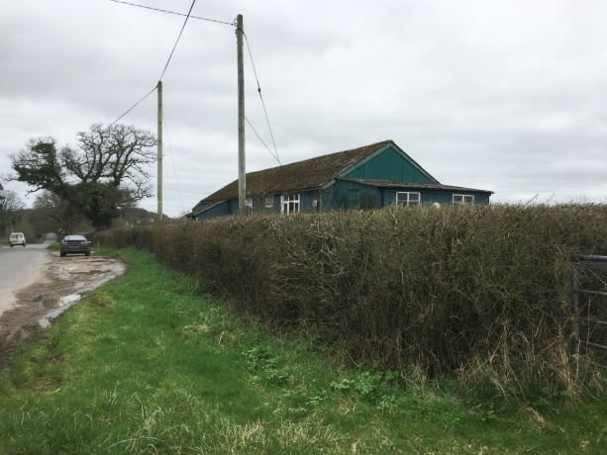
The land on which the hall stands was given to the village in 1923 by the Digby family for the specific purpose of providing a village hall for use by the community. The building itself is an ex-army corrugated iron hut which was erected in 1924 and has since seen little change except the addition of a kitchen area. The freehold of the hall is held by the Official Custodian for Charities in trust for the village hall’s management committee. In 2005, a 50-year lease of the land behind and to the side of the hall was agreed with the Digby family in order to provide adequate and safe off-street parking for users of the hall. [May update this nearer presentation of draft time if matters have progressed.]
In 2011, an informal survey of the hall was made highlighting concerns over the likely life of the hall’s structure, prompting the need to consider the long-term future of the building.
In 2014, the hall committee were approached by a local landowner who offered to transfer the freehold of some two acres of land elsewhere in the parish for the construction of a new hall in return for the committee making a joint planning application for the residential development of the adjoining land. The proposal was put before residents at the Annual General Meeting in May 2016. The majority of residents did not support the proposal, largely reflecting their opposition to the proposed residential development, and the committee withdrew from the joint application.
In 2016, a Village Hall Survey was carried out as part of Holwell’s Neighbourhood Plan process, and demonstrated that the majority of Holwell’s residents viewed the presence of a village hall as an important if not essential part of a village community. Although the majority indicated their preference for the hall remaining at or close to its current location, there was a sharp division of views as to whether the hall should be repaired or replaced.
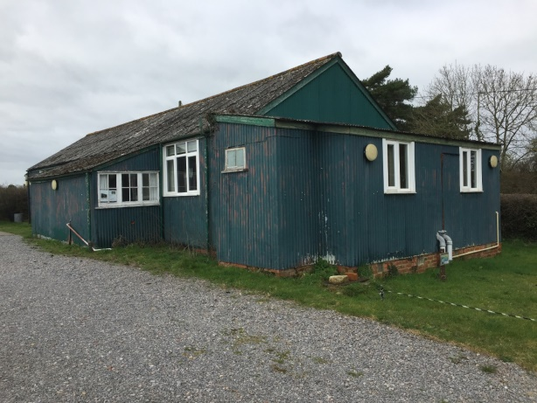
In 2017 the Hall Committee decided to commission an independent feasibility study to investigate the various options in terms of maintaining, repairing, improving or rebuilding the Hall, their cost and timescale. The outcomes will be presented to the village to consider, in conjunction with the funding challenges each option carries, so that the village can make an informed decision as to which option they wish the Committee to pursue. It is anticipated that the feasibility study will be available in May 2018. In the meantime, various repair and maintenance works are being carried out by a group of volunteers to ensure that the hall remains available for use.
The hall is regularly used – on a weekly basis by Dance Fit, Table Tennis and Circuit Training groups, and on a less regular basis by Holwell’s Youth Club, Short Mat Bowls group, a U3A art group and Holwell Women’s Institute. It is also hired on a quarterly basis by BearCat Music for music, poetry and performance evenings and the Village Hall Committee regularly host two Quiz Nights a year and the annual Harvest Supper. Other fundraising events have included car boot sales, a skittles evening with BBQ using the hall’s own skittle alley (brought from its storage at Pulham Rectory) and a Winter Warmer event comprising stalls, raffle and seasonal refreshments. The hall is also let for private parties and other community gatherings such as the Queen’s Jubilee celebrations, and is used for all parish and general elections.
The village hall’s website was established recently and is kept up-to-date with information affecting the village as well as the activities on offer at the hall and fund raising events (see www.holwellvillagedorset.org.uk). The hall also uses email and social media - Facebook - to post information and enable users and potential users of the hall to communicate with the hall’s committee.

Church
The Church of St Laurence is in the Diocese of Salisbury and has been a site of Christian worship for over 700 years. It is the only Grade I-listed building in the parish and the grandeur of its composition illustrates the great wealth that existed in this area during the 15th century due largely to the importance of the local wool trade. It stands in its churchyard in the conservation area of The Borough, one of the earliest hamlets in the parish.
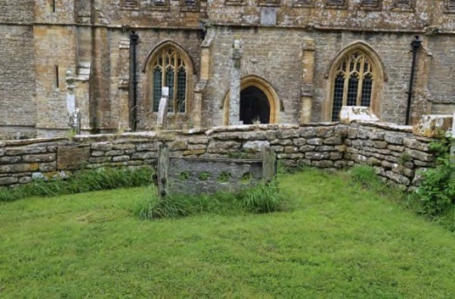
Robert Le Brett donated the land for the church to the abbots of Abbotsbury in 1322 and most of the current church was largely the result of a rebuilding in the early part of the 15th century using coursed limestone rubble with ashlar dressings of the same material, probably from the Marnhull quarries. Although the major part of the church dates back to the 15th century, a gallery was erected in front of the west tower in 1734, and the chancel was rebuilt in 1770 and again in 1885 at a cost of about £1,400, when the organ chamber was added. The church is unusual in that the tower was built some years before the nave.
St Laurence consists of chancel, nave of four bays and aisles, south porch and an embattled western tower with pinnacles. The nave has an early 15th-century wagon-vaulted ceiling and the north chapel a fine 17th-century wooden ceiling with moulded beams and bosses. There are simple late Victorian pews throughout except for the north aisle where a number have been removed, and a late 17th-century pulpit with reeded lower panels. There are memorial windows to members of the Warry family and to Mr Robert English, many years churchwarden, and three medieval sun dials on the south side.
In 2001, the nave roof was discovered to be defective and the church was closed for five years while a new steel roof structure was erected above the existing timbers and the whole extensively restored along with the interior. During this major restoration some of the timbers were found to date back to the 1190’s. While the church was closed, services were held in a neighbouring church or in Holwell village hall, before the church was rededicated in September 2007.
St Laurence is one of the churches covered by the Three Valleys Team and is the biggest parish in the White Hart Vale benefice, having the largest population and covering some 2400 acres. The parish register of baptisms, marriages and burials began in 1653, and the original register books have been digitised and are deposited with the Dorset Archives Service. The church holds two services per month, one Communion and one Evensong. The congregation averages around 20, the Communion service being more popular than Evensong. The peal of five bells is a ground floor ring, made by Gillet and Johnston in 1911, the tenor weighing over 14cwt; the bells are in good order and rung regularly by a local team with ringers occasionally visiting from other parts of the country.

Nursery/School
The village school closed in 1990 and the building now houses Holwell Nursery, a registered charity which is run by a management committee comprising parents of past and present users as well as members of the community. It is affiliated to the Pre-School Learning Alliance and is registered with OFSTED.
The Nursery provides care for pre-school children from 3 months to 4 years of age and is open five days a week (excluding Bank Holidays), for 50 weeks of the year from 8.00am to 5.30pm, closing at Christmas for two weeks. It also provides a Holiday Club for children aged from 5 to 12 years during all school holidays except Christmas.
In light of the persistent problems experienced by users and employees of the Nursery with on-street parking and vehicles dropping-off/picking-up, provision has been made in the Crouch Lane development of affordable housing for additional parking spaces to the rear of the Nursery together with ancillary recreation space.

Public Rights of Way
In the absence of public parks and recreation areas, the main outdoor recreation opportunities in Holwell are reliant on the use of the extensive network of public rights of way. In the Household Questionnaire responses, from December 2016, the options that most people thought may enhance and protect our local area included better access to footpaths/bridleways with more that 100 comments made about the quality of countryside being the reason that people love living in Holwell.
A map showing footpaths, rights of way and bridleways is shown as Appendix I and the latest version of the Footpaths etc listing received from Dorset County Council is dated 29 September 1989 with later updates 14 September 2017 and is attached at Appendix I-2.

Community Policy
The following policy seeks to protect the facilities that we currently enjoy, and allow them to expand. It makes specific provision for improvements to the village hall including a much wanted recreation area. It also defines the broad area in which other community facilities would be welcomed, that is reasonably well-related and accessible to the main population, but the acceptability of proposals would be subject to an impact assessment in terms of environmental, amenity and road safety concerns.

Policy C1: Important Community Facilities
Community facilities listed below should be retained where possible, and every effort should be made to work with the local community to investigate potential solutions to avoid any unnecessary loss of these valued facilities and services. Proposals that would allow such facilities to modernise and adapt for future needs, including complementary facilities that would support their long-term viability, are encouraged.

- Church and churchyard
- Village Hall
- Nursery School
In addition to those listed above, proposals for new facilities will be supported, provided the site is well-related to an existing building, subject to consideration of environmental, road safety and amenity concerns.

The network of public rights of way will be safeguarded, and improvements to provide safer and more accessible routes will be supported.

TRANSPORT, INFRASTRUCTURE AND COMMUNICATION

Road infrastructure and safety
Data from Dorset County Council shows that there have been no serious vehicle collisions reported within the parish over the past 5 years, with three slight vehicle collisions reported on the A3030 near Woodbridge Farm (no details available).
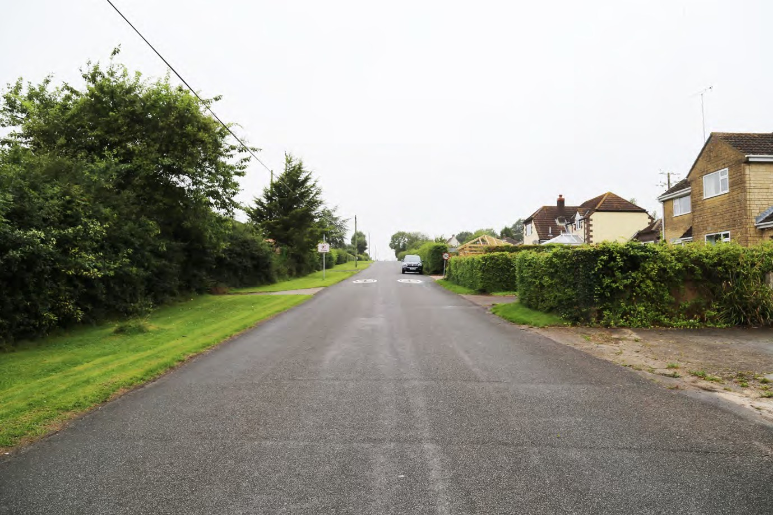
As well as concerns that have been voiced at Parish Council meetings, the Neighbourhood Plan questionnaire in 2016 highlighted that there are some road safety concerns centred on the observance – or lack thereof – of the 30 mph speed limit within which the centre of Holwell sits The width of the verges on Fosters Hill with houses being set well back and the straightness of the road itself combine to contradict the built-up nature of the village and appear to encourage motorists to ignore the 30mph speed limit. Daily traffic associated with the parish’s agricultural nature has also been identified as a cause for concern. Other areas of concern include parked cars around the nursery school, and the junctions of Pulham Road with Holwell Drove and Fosters Hill, as has the lack of street lighting.
Despite evidence of speeding provided by the Community Speedwatch team’s regular monitoring, financial constraints on both the county and parish council have mitigated against preventive measures such as speed bumps or ‘entrance’ gates. The Highways Department proposed several measures as a result of which a Give Way sign has been erected near the junction of Pulham Road with Crouch Lane, and road markings to emphasise the 30mph speed limits have been installed. The Speedwatch team have also received strong support from the Dorset, Devon & Cornwall Police force.

Transport & Infrastructure Policies
No specific policies have been identified, given the broad policies covering road safety in the Local Plan.

LANDSCAPE & ENVIRONMENT and design

Strategic Objective & Policies
To protect and enhance the natural, agricultural and built environment of the Parish including its landscape, built heritage, archaeological sites and wildlife habitats.

To keep development to an agreed scale, of good quality and design, making use of materials that are appropriate, sustainable and complementary to neighbouring properties.

To reduce vulnerability to the impact of severe weather i.e. flooding, etc.

Landscape and Views
The parish’s landscape is predominantly rural and agricultural. The village’s linear layout with a network of roads connecting the various hamlets which lie within the parish ensures that residents have extensive views over the near countryside, as well as more distant views towards local features such as Bulbarrow or Dungeon Hill Fort, and across The Borough towards Bishops Caundle. The parish’s network of footpaths also provides access to views of the surrounding countryside, while many residents enjoy unspoilt views from the privacy of their own homes and gardens.

Some of the most notable views across the countryside are available to travellers along the following roads:
- Holwell Drove – predominantly fields to the north and fields and woodland to the south
- Pulham Road – across woods, fields and rolling farmland especially to the west
- Crouch Lane – east and west over fields with far-reaching views north to The Borough and beyond towards Bishops Caundle on higher ground
- Sandhills Road – looking west over gently sloping open farmland
- Peaceful Lane – fields and rolling farmland to both east and west
- Packers Hill – open farmland to the south east towards the ridge of Bulbarrow
- Road towards Middle Piccadilly – far-reaching views over farmland

The following views are particularly notable for their scenic value and enjoyment:

 | Location and Direction | View Description
View 1 towards Bulbarrow | From various locations along Packers Hill (and from houses along the road) looking south eastwards. | Panoramic view across farmland and open countryside towards Bulbarrow, one of the highest ridges in Dorset.
View 2 towards Dungeon Hill Fort | From various locations within Holwell, notably on Pulham Road and Sandhills Road, looking south. | Panoramic view over farmland and wooded areas towards distant hills.
View 3 towards Bishops Caundle | From Crouch Lane and footpaths north of Penny Farm, looking north. | Panoramic view over farmland and wooded areas towards the village of Bishops Caundle on the other side of the valley. Views of the Grade I Church of St Laurence in the mid-ground.
Table 1 – Important Views

Landscape Policy

Policy E1: Locally Important Views

The important public views, as identified in Table 1 and shown on MAP are to be respected. Development that would significantly intrude and impact on their enjoyment, by virtue of scale, massing, design or location, will be resisted.

Important Green Spaces, Wildlife and Landscape Features
In a rural community like Holwell, well over 90% of land cover is used for agricultural land. A number of areas have been identified as of particular landscape, cultural or wildlife value. There are four Sites of Nature Conservation Interest (SNCI) within the Neighbourhood Plan area. These are
- Peaceful Lane for its Road Verge and Hedgebank
- Some fields on Hill Street Farm for its Semi-improved Neutral Grassland
- Holwell Drove for its Wide Verges and Neutral Grassland and small Pond
- Holwell Gorse for its Secondary Woodland with limited but interesting flora (Figs. 3.1 and 3.2 in SEA).

These have management plans designated by the Dorset Wildlife Trust and planning decisions are required to take them into account. Two of these have adjoining areas which are also of potential wildlife importance. Firstly Peaceful Lane on the western side from the northern end of the SNCI to its junction with the A3030 contains many snowdrops and interestingly, at the Stony Lane junction, Box Buxus sempervirens forms part of the hedge. Secondly, on Holwell Drove, to the east of the SNCI on its northern side, there is a narrow strip of woodland where Common-spotted Orchids and Moschatel both grow.
There is land at Barnes Cross that relates to the historically interesting post box. The verges contain many Common-spotted Orchids. These grow by the hedge on its south-east side between Crouch Hill Lane and Stock Hill Lane although the vegetation here is becoming somewhat rough. In the triangle formed by the lanes there is a Wild Service Tree Sorbus torminalis planted by the Breezes and just south at the first corner in Stock Hill Lane a nightingale was heard singing in the thicket on the left.
Holwell churchyard has a number of interesting plant species. Among the flowers, as well as Snowdrops and Primroses, Wild Daffodil Narcissus pseudonarcissus and Fritillary Fritillaria meleagris are naturalised in the rougher grass to the east of the church while to its north-east both Hop Humulus lupulus and Wild Plum Prunus domestica insititia grow. In good ‘fungus’ years Waxcaps Hygrocybe spp. appear in the shorter turf to the south-west of the church.
There are substantial stands of trees, notably to the south of Holwell Drove, and pockets of woodland are dotted throughout the parish, largely comprising beech, blackthorn, hawthorn, hazel and oaks. Avenues of mature oaks line the driveways to Westrow, Westrow Farm and Little Westrow. However, most of the orchards that were in existence in the 1800s disappeared in the 1930s.
There are a number of Tree Preservation Orders within the parish, the majority of which are along Packers Hill, with others in Fox’s Close and Stony Lane. A number of other trees have been highlighted, including an ancient oak at Hill Street Farm, another in the fields east of Westrow and another in the field north west of the Bursery school.
The general importance of grass verges, hedgerows and woodland lining the secondary roads was also highlighted in the heritage and character appraisal for the area. The parish contains an ancient network of tracks and footpaths, many of which connected the outlying hamlets to The Borough and were widely used by packhorses. For example, one ran from The Borough to Woodbridge Farm over Rowden Mill Bridge. Several tracks are now green lanes such as that from Westrow to Barnes Cross, and the lane originating at Font-le-Roi in Caundle Marsh, that leads to Lower Buckshaw and Holwell Manor. The character of the mile-long Holwell Drove resulted from the last large land enclosure in 1797 – the western end of the Drove was left unfenced as the then landlord did not wish to buy it, whereas the eastern end closest to the centre of Holwell was enclosed and fenced.

Green Spaces & Wildlife Policy

Policy E2: Locally Important Green Spaces, Wildlife and Landscape Features
All woodlands, veteran trees and the wildlife areas identified on map at Appendix J should be protected and managed to sustain them in the long term. Where their loss cannot be avoided, suitable replacement planting that will provide a similar landscape and wildlife benefit should be secured.

Where development is proposed, native hedgerows and mature trees should be retained where possible, or replanted if there is a specific reason why they cannot be retained.

Development that would noticeably detract from the rural character of the lanes and tracks in the parish will not be supported.

All landscaping schemes should be in sympathy with the existing natural landscape and native flora, including the preservation and strengthening of existing wildlife corridors

Buildings and Structures of Local Importance
There are 23 listed buildings and structures within the parish, one of which – the Parish Church of St Laurence – is Grade I listed, while the others are Grade II and 11* listed.
Table 2 : Listed Buildings in Holwell Source Historic England
- Church of St Laurence  - The Rectory  - Holwell Farmhouse  - Cottage south of Holwell Farmhouse  - Bridge north of Church of St Laurence (that part in Holwell)  - Table tomb (south of south aisle) in Church of St Laurence  - Table tomb (east of chancel) in Church of St Laurence  - Pillar box at Barnes Cross (c1853)  - Holwell Manor  - Westrow Cottage West (known as Little Westrow)  - Westrow Cottage East | - Church Hill Farm (ie Crouch Hill Farm)  - Buckshaw House  - Buckshaw Farmhouse  - Lower Buckshaw Farmhouse  - Strawberry Cottage  - Naish Farmhouse  - Elm Tree Farmhouse and outbuildings  - Middle Piccadilly Farmhouse  - Woodbridge Farmhouse  - 2 farm buildings adjacent to Woodbridge Farmhouse  - Rowden Mill Bridge (that part in Holwell)  - Cornford Bridge (that part in Holwell)

More detail on these buildings and structures is shown in Appendix M.
In addition to these, there are other features that residents see as contributing to Holwell’s unique character, Appendix is a list of Locally Important Buildings and Structures and features of Holwell that should be considered in this light. Some examples are listed below and more details are available at Appendix N.

- South View – Methodist Chapel
- The Chapel House
- Holwell Nursery School, Crouch Lane
- Stocks to the south of the church
- Lodges to the north and north-east of Buckshaw House’s Gate
- Holwell Drove
- Peaceful Lane
- Ancient Oak at Hill Street (not covered by a Tree Preservation Order)
- Ancient Oak near Little Westrow (not covered by a Tree Preservation Order)
- Red BT telephone box (K6 design) by village noticeboard.

There is also a range of traditional buildings throughout the area which are associated with farming. These buildings can be divided into two sub-categories: farmhouses and cottages. The majority are constructed of rubble stone; however there are some brick and rendered examples. All are two-storeys high and have features such as porches with pitched roofs, tiled roofs and timber windows. Most of them appear on the 1886 Ordnance Survey map and are good examples of the vernacular architecture of Holwell. They all contribute to the local distinctiveness of the area and are considered to be buildings of local interest

Our historic buildings are protected through Listing, and given strong protection under the relevant legislation, national and Local Plan policies. However there are some buildings in the village that date from the 19th and 20th century (or earlier) that are not currently Listed or on a Local List but which could be considered of local interest and contribute positively to the character and heritage of the area.

Buildings & Structures Policy

Policy E3 : Buildings and Structures of Local Importance
Where feasible, identified Locally Important Buildings and Structures (as shown in Appendix N) should be retained, and development should respect and not detract from their contribution to the historic and architectural character of the area.

Rivers, Waterways and Flooding
The parish is drained by numerous small streams and springs that generally flow northwards towards Caundle Brook, a slow-moving river which often causes water spillage into surrounding fields. There are a number of other water courses and tributaries throughout the village, all of which may break their banks under certain conditions.
Since it is largely Oxford Clay, in periods of prolonged or heavy rain, water can gather rapidly and even higher areas of the parish can flood - parts of Holwell Drove, Fosters Hill, Pulham Road, Stony Lane, Peaceful Lane and Crouch Lane are particularly susceptible. Flooding occurs because culverts and drains pass under roads and may not be able to absorb the full volume of water, or because ditches have been infilled and the piping beneath is inadequate. Blocked drains and ditches are a particular problem in Stony Lane, causing ice formation in cold weather. There have been isolated cases of heavy surface water flooding properties in the past, and farmland can also flood rendering it impossible to put cattle out.
The Working Group reviewed the Flood Maps available for the parish of Holwell to ensure they were aware of the main areas that should be noted throughout the site selection process. With the sites selected and put forward in this Plan, there do not appear to be any flood issues and the Working Group agreed that no specific policies are required.

Design
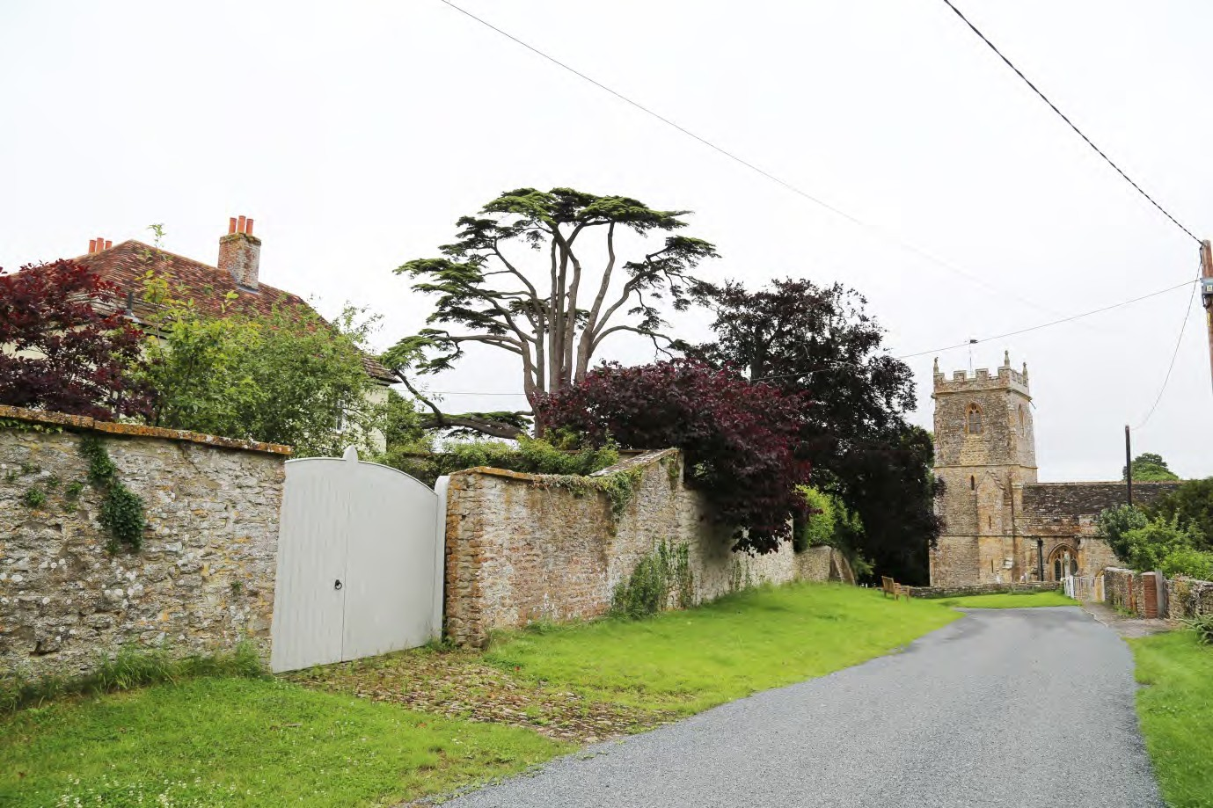
Holwell is a dispersed settlement concentrated mainly along Crouch Lane, Fosters Hill and Pulham Road. The village comprises low-density development of predominantly detached houses set back from the road in large plots, characteristic of a rural area. The typical materials and architectural detailing used throughout Holwell contribute to its local vernacular and reinforce the distinctiveness of the area. Its rural character is reinforced by the extensive verges and gardens which surround most properties, allowing views across the area and beyond to the rural landscape. Away from the main settlements, agricultural buildings also contribute to the rural character of the area.
The design of new buildings should look to enhance local character. Design quality should focus on reinforcing local distinctiveness, but not preclude originality or achieving energy efficient designs. The following provides design guidance that picks up on the distinctive characteristics of this area. Examples are provided in the pages that follow.

Design Policy

Policy E4: Design
Any future development will be designed to reinforce the distinctive rural character of Holwell parish. This should include reference to and consideration of all of the key characteristics, as described in Table 3 below

Aspect | Guidance | Examples
Density, scale and orientation | The scale of development should be appropriate to the size of the plot and general character of the surrounding area.  There should be a positive relationship between the building and the street.  Spacing between buildings should allow for views through to the wider countryside.  New buildings should respect the existing height and roofline of adjoining properties. Extensions should not exceed the height or footprint of the original building.
Building line | The set back of new buildings (as measured from the back of the carriageway to the front elevation) should respect the existing building line along the street
Roof design | Careful attention should be paid to roofing materials, pitch, eaves and verge details and the inclusion of chimney stacks or other features that project above the ridge line. In general, a simple roof form is preferred. A typical palette in Holwell includes clay and slate roof tiles | See Image 3
Doors | Doors should be simple and well-proportioned; pastiche of historical designs should be avoided.  Porches are a common feature in Holwell and can be used to add interest. | See design palette.
Windows | Windows in new houses should complement the vertical pattern and scale of windows reflected in local architectural detailing.  A typical palette in Holwell includes timber painted windows. Paint colours should respect traditional, local colours. For Holwell muted, natural tones are appropriate. | See materials and design palettes
Materials | Materials used in new development should complement the materials typical of the existing buildings in the street, the streetscape or the existing building in the case of extensions. Whilst, exceptionally, an extension may intentionally be designed to be contrasting, such an approach will need to be carefully justified and its success will rely on a high quality design.  A typical palette in Holwell includes rubble stone, red stock bricks.  Permeable surfacing materials should be used to provide adequate natural drainage. | See materials palette.
Architectural quality and detailing | The design and amount and type of decoration and functional elements (such as the position and type of doors and windows, flues, chimneys, gutters and flashings) should complement the local vernacular but avoid overly detailed / pastiche elevations. Traditional elements often include detailing around windows including cills, quoins and masonry detailing, door surrounds or porches and timber framed, sash windows. Existing period detailing should be retained and the covering over or removal of such elements is not encouraged.  The introduction of conspicuous domestic features and additional window or door openings in converted agricultural buildings should be avoided. Retention of existing features and a simple design approach is usually most appropriate. | See design and details palettes.
Front gardens and boundary treatments | New development should reinforce the well-managed network of grass species rich verges, hedgerows and woodland lining the routes through the area, which are characteristic of the rural landscape.  Existing front gardens should be retained.  Boundary treatments such as stone walls, timber fences and vegetated hedgerows are common. Boundary treatments should be common or complimentary to the street. | See Image 1
Soft landscaping | In Holwell the rural landscape is the dominant feature; the buildings secondary.  Landscape schemes should be designed to be as informal and simple as possible, relevant to the rural context.  Native trees and shrubs should be used to reinforce the rural character of the area and screen urban features (such as cycle and bin stores, and hard-surfacing for car parking). There should be no net loss of trees.
Table 3 : Design Policy Key Characteristics

ILLUSTRATIVE EXAMPLES OF BUILDING./DESIGN STYLES IN HOLWELL

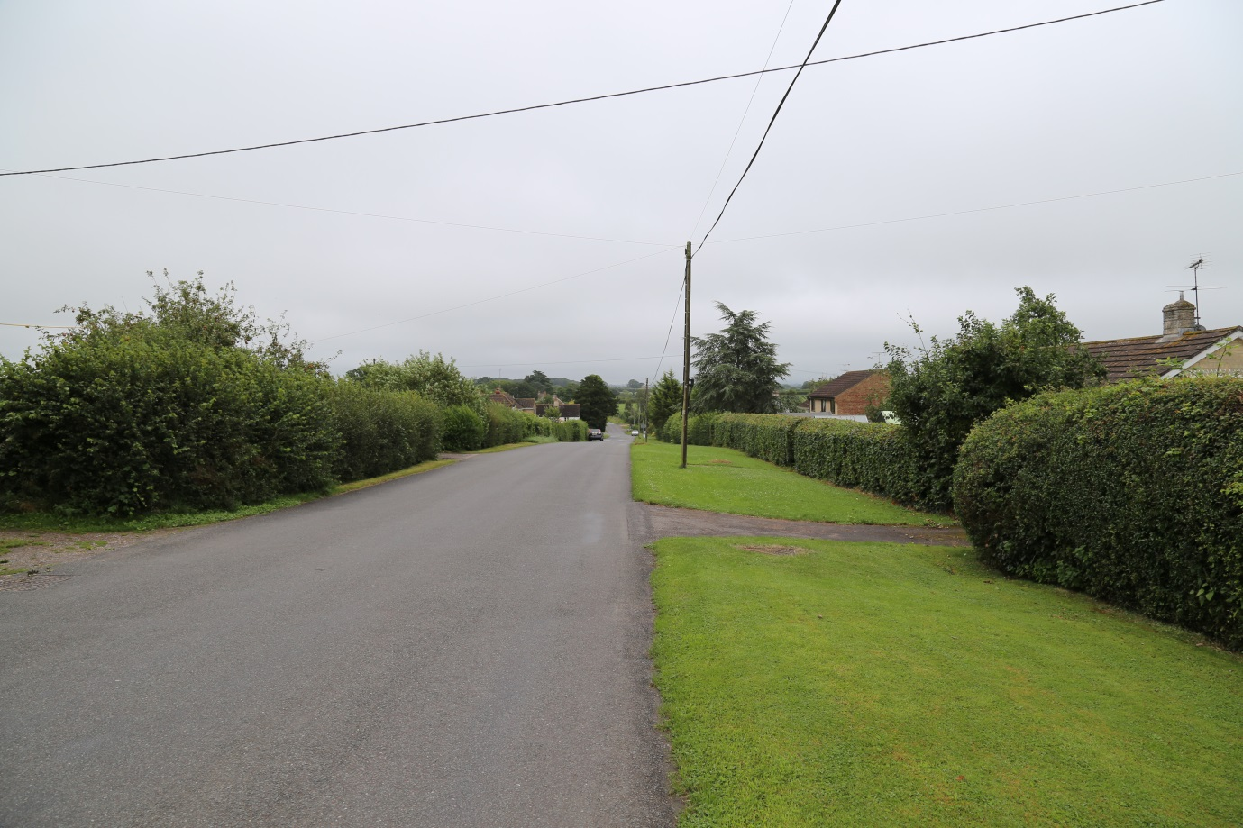
Image 1: Fosters Hill: the main residential street in Holwell
EXISTING PROPERTIES SET BACK BEHIND WELL VEGETATED FRONT GARDENS
WIDE VERGE BETWEEN PROPERTIES AND THE STREET
DENSE HEDGEROW ON PROPERTY BOUNDARIES
VIEWS TO A DISTANT HORIZON

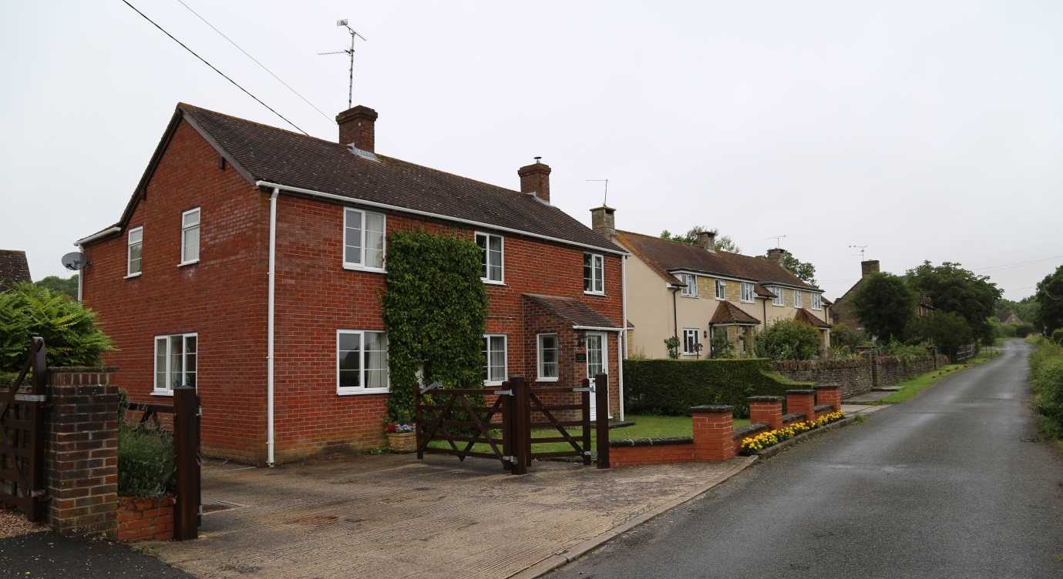
NEW PROPERTY SET BACK FROM STREET RESPECTS THE POSITION OF EXISTING PROPERTIES
Image 2: Stony Lane

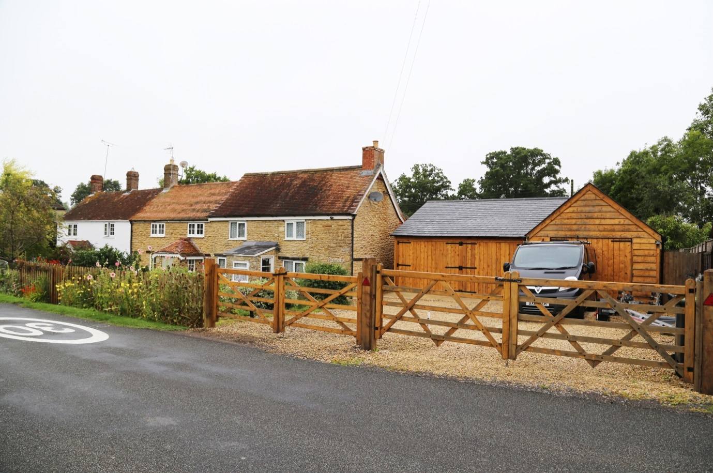
NEW PROPERTY RESPECTS ROOFLINE OF EXISTING PROPERTIES
EXISTING PROPERTIES
Image 3: Cottages, Fosters Hill

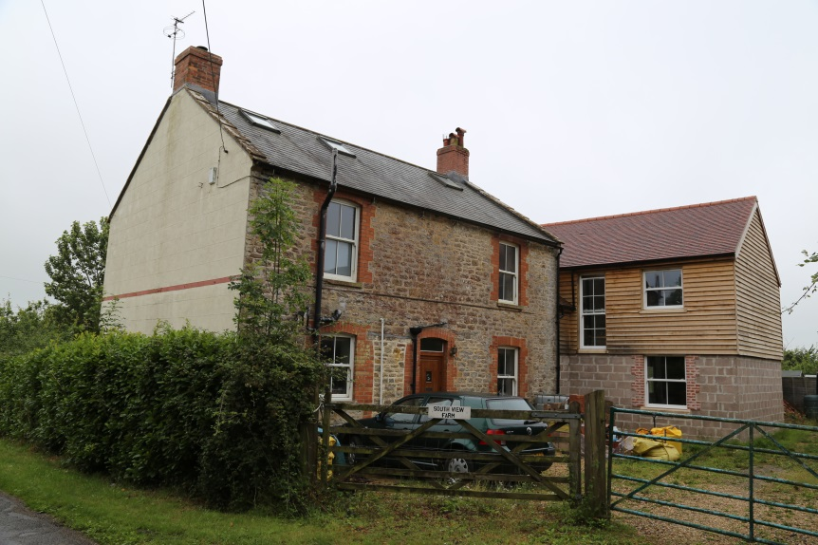
Image 4: Extended property, Pulham Road
NEW EXTENSION RESPECTS SCALE, PROPORTIONS AND ROOFLINE OF EXISTING PROPERTY.

WINDOWS ON NEW EXTENSION HAVE BEEN DESIGNED TO COMPLIMENT THE EXISTING WINDOWS

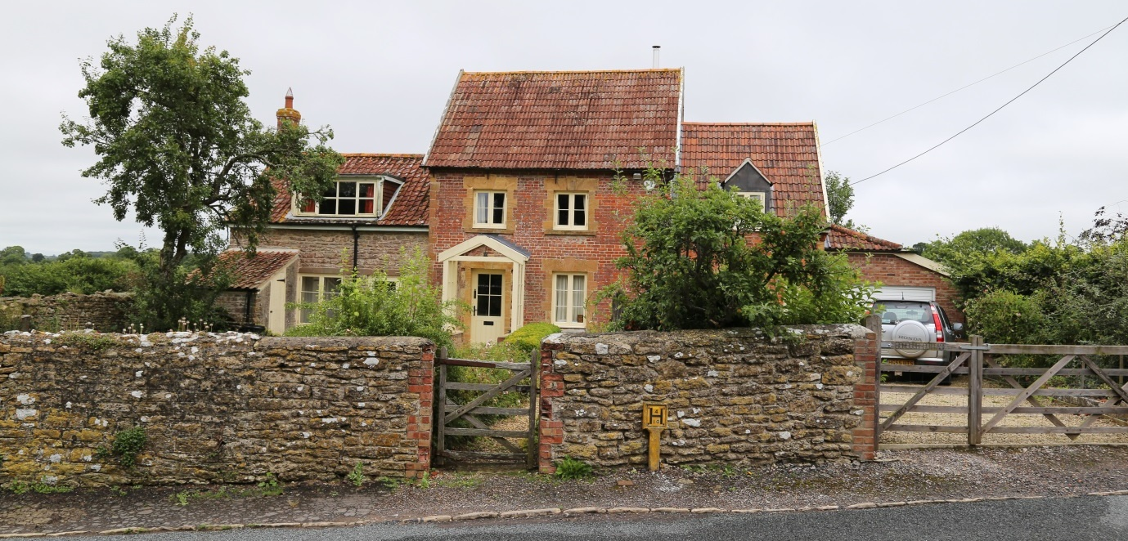
SMALL DORMER WINDOW
MODERN EXTENSION IN SCALE WITH ORIGINAL PROPERTY
RUBBLE
STONE BOUNDARY
QUOIN MASONRY DETAILING
VEGETATED FRONT GARDEN
TIMBER GATE
RED CLAY ROOF TILE
MASONRY DETAIL ABOVE WINDOWS
Image 6: Detached property, The Borough
EXTERNAL PORCH

Materials Palettes
Below are examples of building material that contribute to the local vernacular of Holwell and could be used to inform future development. It should be noted that these materials are not prescriptive and there is opportunity for innovative and creative material suggestions in new buildings, restorations and extensions that may compliment what already exists.

Details Palettes
Below are examples of architectural details that contribute to the local vernacular of Holwell and could be used to inform future development. It should be noted that these materials are not prescriptive and there is opportunity for innovative and creative architectural designs in new buildings, restorations and extensions that may compliment what already exists.

Windows/Chimneys/Additional Features

Masonry Detailing/Porches

Restoration precedents
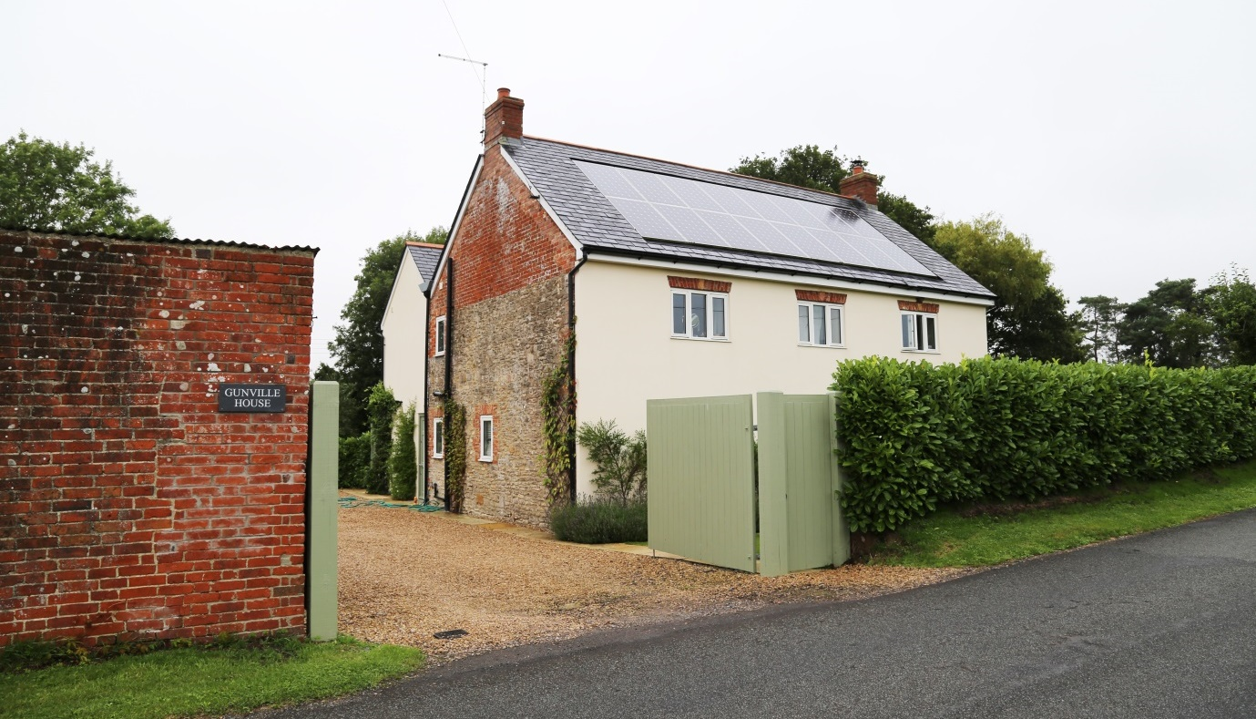
Restored property, Foster’s Hill:

- Masonry detailing above windows
- Mix of facades, render and brick
- Mix of boundary solutions in keeping with the local vernacular, dense hedge, painted timber doors, natural timber and red brick.

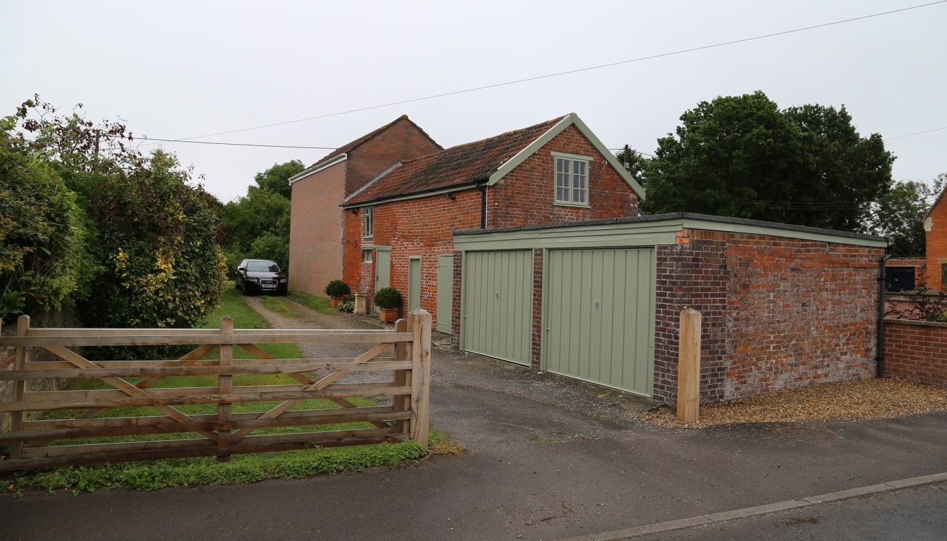
Restored property and outbuilding, Foster’s Hill:

- Painted timber with red brick
- Timber gate

MONITORING AND REVIEW

This Plan is designed to run in parallel with the West Dorset District Council Local Plan that runs until 2031. However this Local Plan is being reviewed and there is also an ongoing review of the National Planning and Policy Framework (NPPF).

It is proposed that the Parish Council consider the need to review this document at least annually with a view to ensuring that it is still current and in line with residents wishes. The decision to review this Plan should take into account any changes to the planning system, ie NPPF or Local Plan that would impact on the content or delivery of this Plan and arrange a more in depth review if required.

APPENDICES, FIGURES AND MAPS

APPENDIX A | SUMMARY OF RESPONSES RECEIVED ON HOLWELL NEIGHBOURHOOD PLAN CONSULTATION FORMS June 2016 - Issue 6
APPENDIX B | SUMMARY FEEDBACK FROM HOUSEHOLD QUESTIONNAIRE DECEMBER 2016
APPENDIX C | STRATEGIC ENVIRONMENTAL ASEESSSMENT SCREENING DOCUMENT
APPENDIX D | HERITAGE AND CHARACTER ASSESSMENT – AECOM REPORT
APPENDIX E | PLANNING DESIGN GUIDANCE – AECOM REPORT
APPENDIX F | SITE OPTIONS CONSULTATION – DETAILS OF SITES REVIEWED BY NEIGHBOURHOOD PLAN WORKING GROUP, MAY 2017
APPENDIX G | MAP INDICATING LOCATION OF SITES SELECTED FOR OPEN MARKET HOUSING IN LINE WITH POLICY H1
APPENDIX H | MAP INDICATING LOCATION OF SITE SELECTED FOR FURTHER AFFORDABLE HOUSING IN LINE WITH POLICY H2
APPENDIX I | APPENDIX I - MAP OF FOOTPATHS BRIDLEWAYS AND RIGHTS OF WAY FOR HOLWELL
APPENDIX 1.2 | APPENDIX I-2 HOLWELL DEFINITIVE STAEMENT 14092017
APPENDIX J | EXTRACT FROM STRATEGIC ENVIRONMENTAL ASSESSENT SCREENING DOCUMENT SHOWING ENVIRONMENTAL DESIGNATIONS WITH HOLWELL NEIGHBOURHOOD PLAN AREA
APPENDIX K | ALL SITES REVIEWED AS PART OF NEIGHBOURHOOD PLAN INCLUDING THOSE WITH CURRENT PP_SHLAA SITES
APPENDIX L | ECOLOGY NETWORK MAP
APPENDIX M | DETAILS OF LISTED BUILDINGS IN HOLWELL
APPENDIX N | LOCALLY IMPORTANT BUILDINGS AND STRUCTURES
APPENDIX P | FEEDBACK ON ENVIRONMENT FROM HOUSEHOLD QUESTIONNAIRE
FIGURE 1 | MAP OF PARISH OF HOLWELL SHOWING AGREED PLAN AREA

