Holwell Neighbourhood Plan

Strategic Environmental Assessment Screening Report

July 2017

CONTENTS

- Introduction 1
- Legislative background to Strategic Environmental Assessment 2
- The Holwell Neighbourhood Plan 3
The Characteristics of the Holwell Neighbourhood Plan Area 3
The Objectives of the Holwell Neighbourhood Plan 5
Scope of the Holwell Neighbourhood Plan 6
- SEA screening of the Holwell Neighbourhood Plan 7
Is the Holwell Neighbourhood Plan likely to have a significant effect on the environment? 8
- Conclusion 14
Appendix A: Consultation Responses 15

1. INTRODUCTION
The purpose of this report is to determine whether or not the Holwell Neighbourhood Plan requires a Strategic Environmental Assessment (SEA) through a process known as SEA screening.

This report provides details of the proposed Holwell Neighbourhood Plan and explains the legislative background to SEA screening, before providing an account of the SEA screening exercise for the Holwell Neighbourhood Plan.

This report meets the requirements of European Directive 2001/42/EC on the Assessment of the Effects of Certain Plans and Programmes on the Environment and the Environmental Assessment of Plan and Programmes Regulations (2004).

2. LEGISLATIVE BACKGROUND TO STRATEGIC ENVIRONMENTAL ASSESSMENT
European Directive 2001/42/EC on the Assessment of the Effects of Certain Plans and Programmes on the Environment (‘SEA Directive’) introduces the need to undertake a strategic environmental assessment (‘SEA’) during the development of some plans and programmes. The main purpose of SEA, according to Article 1 of the SEA Directive, is:
“to provide for a high level of protection of the environment and to contribute to the integration of environmental considerations into the preparation and adoption of plans and programmes with a view to promoting sustainable development”.
The SEA Directive is transcribed into UK law through the Environmental Assessment of Plans and Programmes Regulations 2004, which establishes the requirement to undertake a sustainability appraisal (‘SA’) for some documents used for planning purposes. The SA process incorporates the requirement for SEA, but typically has a broader scope and considers the social and economic issues in addition to the environmental effects.

The requirement to undertake an SA of supplementary planning documents (SPD) was removed by the Planning Act 2008. However, the need to establish whether the planning document requires an SEA, through the SEA Directive, remains.

Articles 2 and 3 of the SEA Directive explain which plans and programmes require SEA. The Government’s Planning Practice Guidance suggests that an SPD will only require an SEA “in exceptional circumstances…if they are likely to have significant environmental effects that have not already have been assessed during the preparation of the Local Plan”.

The Neighbourhood Planning (General) (Amendment) Regulations 2015 amends the Neighbourhood Planning (General) Regulations 2012 to provide clarification on the SEA related documents which must be submitted alongside neighbourhood planning proposals. Regulation 2(4) of the amendment regulations 2015 adds to the list of documents that a neighbourhood planning group must submit to a local planning authority with a proposal for a neighbourhood plan, which is presented in regulation 6 of the Neighbourhood Planning Regulations 2012. The additional document which must be submitted is either an environmental report, should an SEA be required, or a statement of reasons why an environmental assessment is not required.

3. THE HOLWELL NEIGHBOURHOOD PLAN

THE CHARACTERISTICS OF THE HOLWELL NEIGHBOURHOOD PLAN AREA
The Holwell Neighbourhood plan area occupies the whole of the civil parish of Holwell, covering an area of approximately 977 hectares (Figure 3.1) and a population of approximately 349¹.
The Holwell Neighbourhood Plan area and surrounding areas include a number of environmental designations, particularly relating to wildlife, heritage assets, and flooding, indicating the importance and sensitivity of the plan area from an environmental perspective (Figure 3.1).
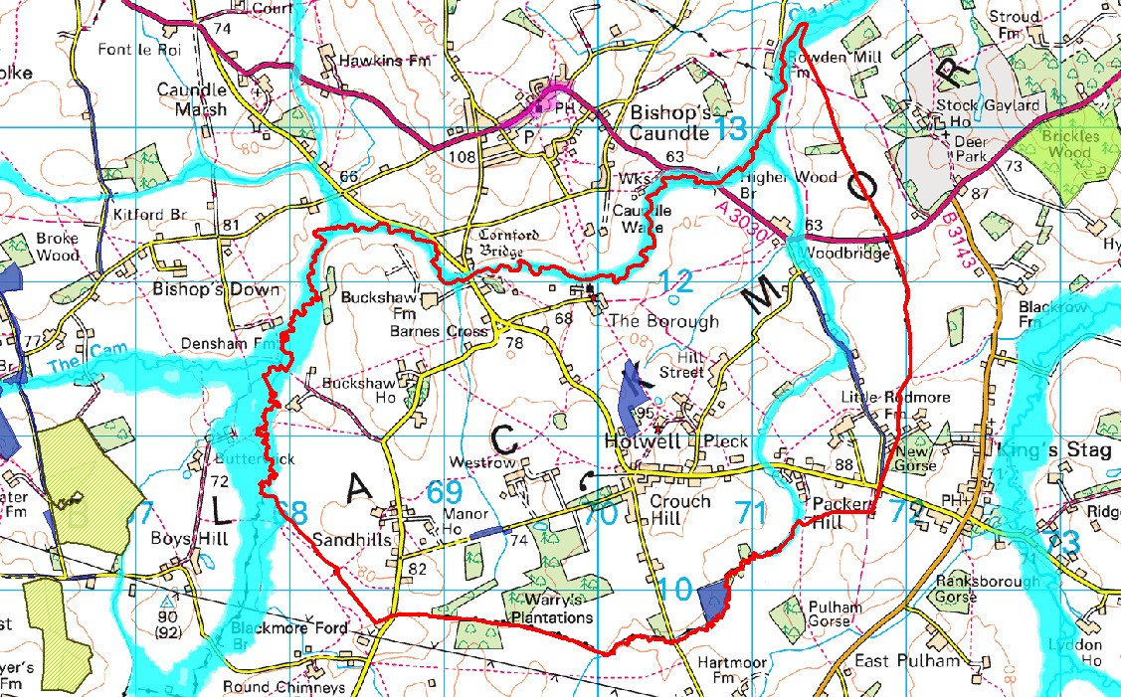
Figure 3.1: Environmental designations within the Holwell Neighbourhood Plan area
© Crown Copyright and database right (2017). Ordnance Survey Licence number 100024307. © and Database rights Environment Agency 2016. All rights reserved. Some of the information within the Flood Map is based in part on digital spatial data licensed from the Centre for Ecology and Hydrology © NERC. © Historic England 2016. © Crown Copyright. All rights reserved 2016
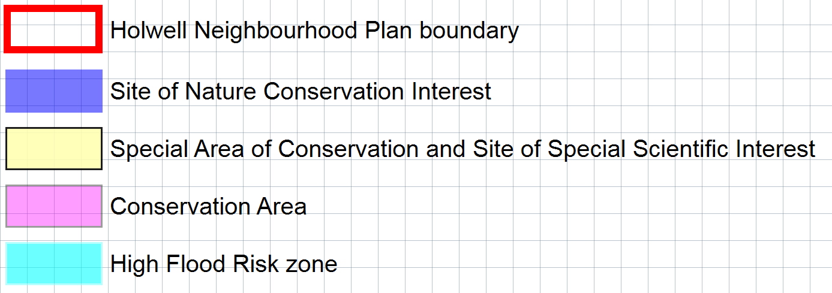
Legend

1 According to the 2014 mid-year estimates released by the Office for National Statistics

The wildlife designations within the Holwell Neighbourhood Plan area include Sites of Nature Conservation Interest (SNCI) which are local wildlife designations (Figure 3.2).
Figure 3.2: The Sites of Nature Conservation Interest (SNCI) within the Holwell Neighbourhood Plan area

Name of SNCI | Area | Description
Peaceful Lane | 2.7ha | Road verge and hedgebank with neutral grassland flora.
Hill Street Farm | 4.9ha | Semi-improved neutral grassland.
Holwell Drove | 0.9ha | Wide verges with a good neutral grassland flora, plus a small pond.
Holwell Gorse | 3.8ha | Secondary woodland with a limited but interesting flora.
The areas surrounding the Holwell Neighbourhood Plan Area include the Sites of Special Scientific Interest (SSSI), which are national wildlife designations, which are presented in Figure 3.3.
Figure 3.3: The Sites of Special Scientific Interest (SSSI) in the areas surrounding the Holwell Neighbourhood Plan area.

Name of SSSI | Approx. Area | Approx. Distance from NP area | Reason for designation
Blackmore Vale Commons And Moors SSSI | 275ha | 260m to the east | Blackmore Vale Commons and Moors SSSI supports a diverse mosaic of semi-natural habitats, including unimproved grasslands, ancient semi-natural woodland and wood pasture, scrub, and an extensive network of hedges, with small wetlands, ponds and waterways.
Holnest SSSI | 54ha | 745m to the west | The SSSI is a nationally important site because it supports a large population of great crested newts (Triturus cristatus) on the south-western edge of their range. The SSSI consists of two areas, which include breeding ponds and terrestrial habitat that is used by  the newts for resting, foraging and hibernation.
In addition, the Special Areas of Conservation (SAC), which is an international wildlife designation, in the areas surrounding the site are presented in Figure 3.4.

Figure 3.4: The Special Areas of Conservation (SAC) in the areas surrounding the Holwell Neighbourhood Plan area.

Name of SAC | Approx. Area | Approx. Distance from NP area | Reason for designation
Rooksmoor SAC | 62ha | 1450m  to the east | Molinia meadows on calcareous, peaty or clayey-silt- laden soils (Molinion caeruleae) for which the area is considered to support a significant presence.  Euphydryas (Eurodryas, Hypodryas) aurinia for which this is considered to be one of the best areas in the  United Kingdom.
Holnest SAC | 54ha | 745m to the west | Holnest encompasses around 20 ponds set in a matrix of terrestrial habitats, comprising areas of semi- improved grassland, scrub, associated semi-natural habitats and woodland bounded by fences and hedgerows. The ponds exhibit a range of sizes, profiles and origins, and include some recently-created ornamental ponds as well as traditional farm ponds. A large population of Great crested newts (Triturus cristatus) is present, with over 200 individuals having been recorded at one pond in spring 2003. The woodland areas provide ideal hibernation habitat.
The heritage assets in the plan area include the Grade I listed Church of St Lawrence, and the Grade II* listed Buckshaw House, Manor House, Naish Farmhouse, Pillar Box at Barnes Cross, and The Rectory. The Scheduled Monument titled “Hillfort and later strip lynchets on Dungeon Hill, 500m north of Castle Hill Cottages” is approximately 220m to the south of the Holwell Neighbourhood Plan Area.
A high risk flood zone, associated with the local river system, occupies the northern and western boundaries of the Holwell Neighbourhood Plan Area and traverses the eastern section of the site in a north to south orientation.
These are the main environmental considerations within the Holwell Neighbourhood Plan Area which will need to be given consideration during the Plan’s preparation. Other significant considerations not mentioned above should be referenced in detailed responses from the statutory consultees as part of the SEA screening consultation. In addition, other local factors and constraints will also need to be considered.

THE OBJECTIVES OF THE HOLWELL NEIGHBOURHOOD PLAN
The Holwell Neighbourhood Plan intends to give residents the opportunity to influence the future of the area by having a say into future development, regeneration and conservation.
The Holwell Neighbourhood Plan has the Mission Statement:

“To maintain Holwell Parish as a thriving rural community and to ensure its long term future by working towards meeting the needs of those wish to live and work in this community.”
The Holwell Neighbourhood Plan has the following strategic objectives:
  - To meet diverse local housing needs taking into account changing demographics and social requirements;
  - To keep housing development to an agreed scale, of good quality and design, making use of materials that are appropriate, sustainable and complementary to neighbouring properties;
  - To support existing business, encourage new enterprises and facilities which will enhance commercial effectiveness and employment opportunities;
  - To preserve the long term future of the area by retaining and, if possible, enhancing local services, infrastructure and facilities, promoting a safe and healthy community;
  - To protect and enhance the natural, agricultural and built environment of the Parish including its landscape, built heritage, archaeological sites and wildlife habitats; and
  - To reduce vulnerability to the impact of severe weather i.e. flooding, etc.

SCOPE OF THE HOLWELL NEIGHBOURHOOD PLAN
The Holwell Neighbourhood Plan is at an early stage of development, with feedback from the community gathered in March 2016 and other evidence currently being collected to facilitate the development of the plan.
Whilst specific details of the contents of the plan are not known at this stage, early indications are that the Holwell Neighbourhood Plan will provide in the region of an additional 6 dwellings, on top of the 20 homes which already have consent, resulting in 26 new dwellings over the plan period of 15 years. This is likely to be achieved mainly through infill development and conversion of existing buildings rather than greenfield development, reflecting the wishes of the community expressed through a local survey.
The Holwell Neighbourhood Plan also intends to propose a village hall and recreation area, and may look to bring forward a tourist / recreation proposal.
The West Dorset, Weymouth & Portland Local Plan already provides a policy framework which the Holwell Neighbourhood Plan must conform with. The purpose of the policies in the Holwell Neighbourhood Plan is to seek to deliver development against the objectives specific to the area (presented in the section above).

4. SEA SCREENING OF THE HOLWELL NEIGHBOURHOOD PLAN
This Chapter provides an account of the SEA screening exercise for the Holwell Neighbourhood Plan.
Articles 2 and 3 of the SEA Directive provide the legislative framework for defining the types of plan and programme that require SEA.
The SEA screening process is summarised in diagrammatic form in the flowchart shown in Figure 4.1². The screening for the Holwell Neighbourhood Plan is highlighted in Figure 4.1 in orange and justification for the decisions made at each stage in the SEA screening process is given in Figure 4.2.
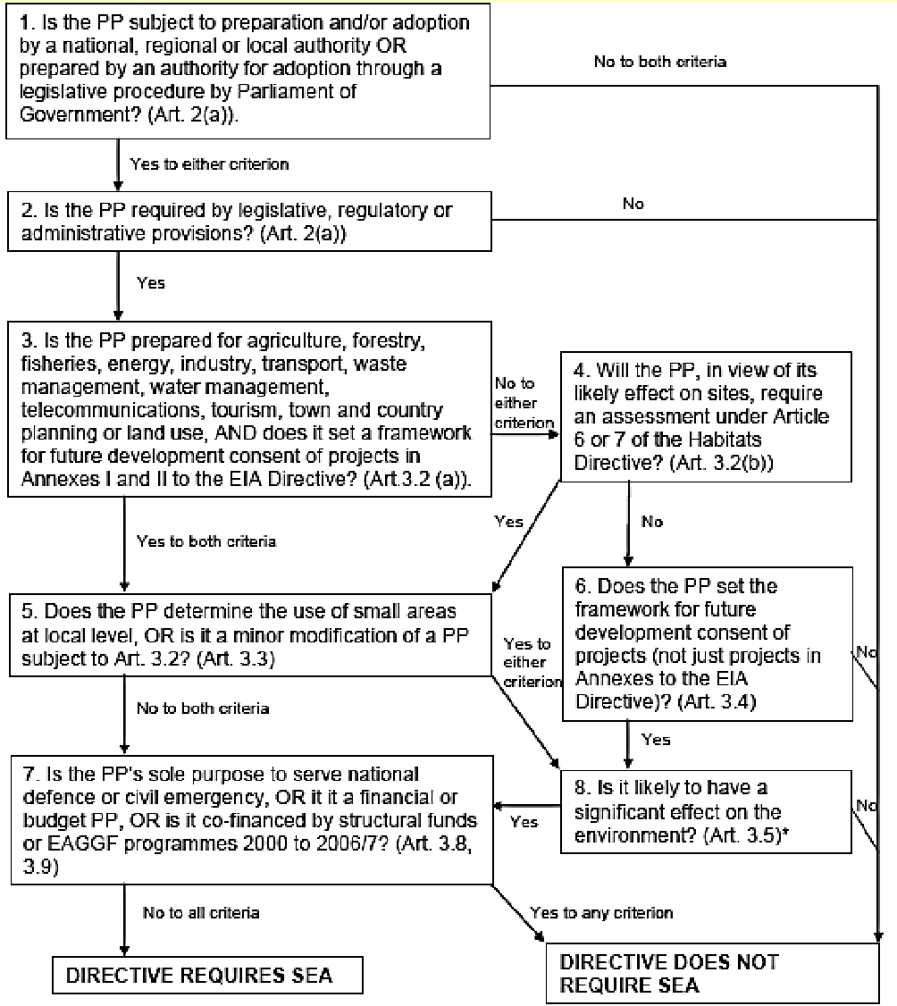
Figure 4.1: A diagram summarising the SEA screening process with the SEA screening for the Holwell Neighbourhood Plan outlined in orange.

2 Diagram taken from the Government guidance on the Strategic Environmental Assessment regulations titled ‘A Practical Guide to the Strategic Environmental Assessment Directive’, published by the Office of the Deputy Prime Minister in 2005

Figure 4.2 – a summary of the justification made for the decisions during the SEA screening for the Holwell Neighbourhood Plan.

Question in SEA screening flow chart (Figure 4.1) | Response
1. Is the PP subject to preparation and/or adoption by a national, regional or local authority OR prepared by an authority for adoption through a legislative procedure by Parliament of Government? | YES  The intention is for the Holwell Neighbourhood Plan to be adopted by West Dorset District Council, a local authority, through a legislative procedure.
2. Is the PP required by legislative, regulatory or administrative provisions? | YES  The Holwell Neighbourhood Plan would be a Statutory document, prepared in accordance with the Neighbourhood Planning (General)  Regulations 2012 as amended.
3. Is the PP prepared for agriculture, forestry, fisheries, energy, industry, transport, waste management, water management, telecommunications, tourism, town and country planning or land use, AND does it set a framework for future development consent of projects in Annexes I and II to the EIA Directive? | YES  The Holwell Neighbourhood Plan is a document prepared for town and country planning purposes, and may indicate where future development which falls under Annex II of the EIA Directive which includes urban development projects under paragraph 10(b).
5. Does the PP determine the use of small areas  at local level, OR is it a minor modification of a PP subject to Art. 3.2? | YES  The Holwell Neighbourhood Plan determines the use of small areas at a local level.
8. Is it likely to have a significant effect on the environment (Article 3.5)? | NO  Justification for this decision is given later in this chapter.
IS THE HOLWELL NEIGHBOURHOOD PLAN LIKELY TO HAVE A SIGNIFICANT EFFECT ON THE ENVIRONMENT?
The final question in the SEA screening process presented in Figures 4.1 and 4.2 for the Holwell Neighbourhood Plan was question 8: Is it likely to have a significant effect on the environment?

In asking this question, the SEA Directive refers to Article 3.5, which states that the relevant criteria in Annex II of the SEA Directive shall be taken into account when determining whether there are likely to be significant effects. Therefore, the criteria in Article 3.5 have been taken into consideration when determining whether the Holwell Neighbourhood Plan requires SEA, as presented in Figure 4.3.

Figure 4.3: The assessment of the likely significance of effects of the Holwell Neighbourhood Plan (Taken from Annex II of the SEA Directive)

Criteria in Annex II of the SEA Directive | Response | Is there a significant effect?
(1) Characteristics of the plan and programmes, having regard, in particular, to:
a) The degree to which the plan or programme sets a framework for projects and other activities, either with regard to the location, nature, size, and operating conditions or by allocating resources. | The framework for development projects within the Holwell Neighbourhood Plan area is set by the West Dorset, Weymouth & Portland Local Plan (‘Local Plan’), which provides the overarching policy for the location, size and nature of development projects in this area. The Holwell Neighbourhood Plan builds upon this framework by providing further details of development projects within this area, potentially allocating land for 26 dwellings (of which permission is already granted for 20 of these dwellings), a village hall and recreational area, and a tourist/recreation proposal. | No
b) The degree to which the plan or programme influences other plans or programmes including those in a hierarchy. | The Holwell Neighbourhood Plan will be adopted alongside its parent document, the Local Plan. The Holwell Neighbourhood Plan will expand upon the existing policies in the Local Plan, providing supplementary information on a local scale rather than influencing the Local Plan. | No
c) The relevance of the plan or programme for the integration of environmental considerations in particular with a view to promoting sustainable development. | Any development which comes forward through the Holwell Neighbourhood Plan will be subject to the environmental considerations of the Local Plan, the aim of which is to achieve sustainable development. | No
d) Environmental problems relevant to the plan or programme. | The environmental problems within the Holwell Neighbourhood plan area are not considered exclusive to the area, and are similar to those considered and addressed in the Local Plan. | No
e) The relevance of the plan or programme for the | The implementation of community legislation is unlikely to be significantly compromised by the | No

implementation of community legislation on the environment (e.g plans and programmes linked to waste management or water protection). | Holwell Neighbourhood Plan.
(2) Characteristics of the effects and of the area likely to be affected, having regard, in particular, to:
a) The probability, duration, frequency, and reversibility of the effects. | It is anticipated that the plan period will be 15 years. Whilst some effects of the plan may be irreversible, it is not considered probable that the plan will have significant effect since it is only likely to bring forward in the region of 6 additional dwellings, above the 20 dwellings which already have consent, and possibly a village hall and recreational facilities over this period. | No
b) The cumulative nature of the effects. | The Cerne Valley Neighbourhood Plan area is located approximately 600m to the southwest of the site. The Cerne Valley Neighbourhood Plan extends the development boundary to the north and west of Cerne Abbas resulting in a modest amount of development. It is therefore considered unlikely that the degree of development proposed through the Cerne Valley Neighbourhood Plan, when considered in combination with the proposals likely to come forward through the Holwell Neighbourhood Plan and the Local Plan, will introduce significant environmental effects. | No
c) The transboundary nature of the effects. | The transboundary impacts, beyond the Holwell Neighbourhood Plan area, are unlikely to be significant in light of the nature and scale of the proposals. | No
d) The risks to human health or the environment (e.g due to accidents). | The Holwell Neighbourhood Plan is unlikely to introduce significant risks to human health and the environment, for example due to accidents, in light of the scale and type the development. | No
e) The magnitude and spatial extent of the effects (geographical area and size of the population likely to be | The Holwell Neighbourhood Plan area occupies approximately 977ha and a population of 349 people according to the 2014 mid year estimates produced by the Office for National Statistics. The spatial extent of the Holwell Neighbourhood Plan | No

affected). | area and the magnitude of the population affected are not considered of a significant scale for the purposes of SEA.
- The value and vulnerability of the area likely to be affected due to:  - Special natural characteristics or cultural heritage | The Holwell Neighbourhood Plan area and its surroundings contain environmental designations which reflect its special natural characteristics and rich cultural heritage.  The plan area includes Sites of Nature Conservation Importance (SNCI) which are local wildlife designations which include roadside verges, semi-improved grassland and secondary woodland. The Holwell Neighbourhood Plan has the strategic objective of protecting and enhancing the natural environment, and in consideration of the scale of the development which is likely to be brought forward through the Holwell Neighbourhood Plan and the characteristics of the SNCI, it is considered unlikely that the plan will result in significant impacts upon these local wildlife sites. The greatest threats to the national and European wildlife designations in the surrounding areas are additional recreational pressure, land management and change in land use (Holnest SSSI and SAC), and air pollution (Rooksmoor SAC). It is considered unlikely that the Holwell Neighbourhood Plan will significantly increase recreational pressure, compromise air quality issues or affect land management practices, once again due to the strategic objectives of the plan and the scale of the development which it is likely to bring forward, and the proximity of these wildlife sites from the development.  The cultural and heritage designations within the plan area include Listed Buildings, with the surrounding areas containing a Scheduled Monument to the south and a Conservation Area to the north. The strategic objectives of the plan include protecting and enhancing built environment of the Parish including its built heritage and archaeological sites, and keeping housing development to an agreed scale, of good quality and design, making use of materials that are appropriate, sustainable and complementary to neighbouring properties. Furthermore, the | No

 | Holwell Neighbourhood Plan will be in general conformity with policy ENV 4 of the Local Plan, which ensures that new development does not result in unacceptable impacts upon heritage assets. Therefore, it is considered that the amount of development which is likely to come forward through the Holwell Neighbourhood Plan will not result in significant impacts upon heritage features.
ii) Exceeded environmental quality standards or limit values | The Holwell Neighbourhood Plan is unlikely to result in the exceedance of environmental quality standards, such as those relating to air, water and soil quality, due to the nature and scale of the development. | No
iii) Intensive land- use | The Holwell Neighbourhood Plan is unlikely to bring forward development of an extent which would result in a significant intensification of land use in light of the scale of development. | No
g) The effects on areas | The environmental designations within the Holwell
or landscapes which | Neighbourhood Plan area and it’s surrounding
have a recognised | areas include:
national, Community  or international protection status. | - Special Area of Conservation;  - Site of Special Scientific Interest;  - Site of Nature Conservation Interest;  - Scheduled Monuments;  - Conservation Area; and  - Listed Buildings.
 | Policy ENV 2 of the Local Plan prevents
 | development which would cause unacceptable
 | impacts upon wildlife sites, including the Special  Area of Conservation, Sites of Special Scientific | No
 | Interest and Sites of Nature Conservation Interest
 | wildlife designations across West Dorset,
 | Weymouth & Portland, including those within or
 | close to the Holwell Neighbourhood Plan area. The
 | development which comes forward through the
 | Holwell Neighbourhood Plan is likely to be of a
 | small scale and focussed towards the existing
 | settlement rather than designated wildlife sites or
 | undeveloped countryside habitats.
 | Policy ENV 4 of the Local Plan prevents
 | development which would cause unacceptable
 | impacts upon designated heritage assets, such as

the Listed Buildings, Conservation Areas and Scheduled Monuments across West Dorset, Weymouth & Portland, including the Holwell Neighbourhood Plan area. The relatively small amount of development which is likely to come forward through the Holwell Neighbourhood Plan will be focusing development towards the existing developed areas, rather than the Scheduled Monuments to the south of the plan area.
However, directing development toward the existing developed areas may result in development occurring in proximity to Listed Buildings. Although the scale of the proposed development, alongside the protection provided by policy ENV4, will act to minimise the impact on listed buildings, the potential for an impact will need to be given careful consideration as the Plan proceeds.

5. CONCLUSION

Having considered the environmental designations and constraints outlined in this screening report, it is considered that the scale of development being considered in the Holwell Neighbourhood Plan, in combination with that already benefiting from planning permission, is unlikely to have significant effects on the environment.

Natural England, Historic England, and the Environment Agency were consulted on the contents of the SEA screening report in accordance with regulation 9(2) of the Environmental Assessment of Plans and Programmes Regulations (2004). A two month consultation was undertaken between May and July 2017.

Natural England and the Environment Agency responded to the consultation and agreed with the conclusion that the Holwell Neighbourhood Plan is unlikely to have significant environmental effects (see responses in Appendix A). Historic England did not respond to the consultation.

Following the consultation, this SEA screening report concludes that the Holwell SEA is unlikely to result in significant environmental impacts and therefore a full SEA is not required in this instance.

This report provides the statement of reasons for the determination that SEA is not required in accordance with regulation 9(1) of the Environmental Assessment of Plans and Programmes Regulations (2004). This document must be submitted alongside neighbourhood planning proposals, as required by the Neighbourhood Planning (General) Regulations 2012, as amended.

APPENDIX A: CONSULTATION RESPONSES

Oliver Rendle

From: Holm, Michael <michael.holm@environment-agency.gov.uk>
Sent: 12 June 2017 14:39
To: Oliver Rendle
Cc: 'jo@dorsetplanning.co.uk'; 'sallyannemholt@aol.com'; Terry Sneller; Victoria Martin Subject: RE: Holwell Neighbourhood Plan: Strategic Environmental Assessment Screening Report Attachments: dps1.rtf

Dear Oliver
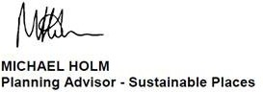
Apologies for the delay in responding. Whilst we have no objection or comments a formal response is attached. Yours sincerely

Planning Advisor for Dorset and South Somerset Direct Dial: 02030 259358
Internal: 59358
Email: michael.holm@environment-agency.gov.uk

The Environment Agency has an email file transfer limit of 8MB. If you wish to send large files to my team please reply to our swx.sp@environment-agency.gov.uk/swx.sp@environment-agency.gov.uk in –box and request a Sharefile link to be emailed to you. With this you can upload files of larger sizes to us.


From: Oliver Rendle [mailto:ORendle@dorset.gov.uk]
Sent: 09 June 2017 12:28
To: 'John Stobart' ; Holm, Michael ; 'Jenny.Chesher@HistoricEngland.org.uk'
Cc: 'jo@dorsetplanning.co.uk' ; 'sallyannemholt@aol.com' ; Terry Sneller ; Victoria Martin
Subject: RE: Holwell Neighbourhood Plan: Strategic Environmental Assessment Screening Report Dear All,
Further to my email below, we are now going finalise the Strategic Environmental Assessment (SEA) screening report for the Holwell Neighbourhood Plan and make a decision regarding the need for SEA. Should you have any comments which you would like us to take into account, then please can you send them to me.

Regards, Oliver

From: Oliver Rendle
Sent: 12 May 2017 10:51
To: John Stobart; Holm, Michael (michael.holm@environment-agency.gov.uk); 'Jenny.Chesher@HistoricEngland.org.uk'
Cc: jo@dorsetplanning.co.uk; 'sallyannemholt@aol.com'; Terry Sneller; Victoria Martin
Subject: Holwell Neighbourhood Plan: Strategic Environmental Assessment Screening Report

Dear All,

I am writing to consult you on the Strategic Environmental Assessment (SEA) screening report for the Holwell Neighbourhood Plan (attached), in accordance with Article 3.6 of European Directive 2001/42/EC.

Please can you respond by Friday 2nd June 2017, to allow for your responses to be taken into account and a decision to be made regarding the need for SEA.

Please don’t hesitate to contact me if you have any questions about this, Thanks,
Oliver Rendle
Environmental Assessment Officer

Dorset Councils’ Partnership serving:
North Dorset District Council, West Dorset District Council and Weymouth & Portland Borough Council

01305 251010 (extension 2557) orendle@dorset.gov.uk www.dorsetforyou.com/contactus

For the latest council news and information sign up to www.dorsetforyou.com/e-news twitter.com/dorsetforyou
facebook.com/dorsetforyou

Disclaimer

This e-mail is intended for the named addressee(s) only and may contain information about individuals or other sensitive information and should be handled accordingly. Unless you are the named addressee (or authorised to receive it for the addressee) you may not copy or use it, or disclose it to anyone else. If you have received this email in error, kindly disregard the content of the message and notify the sender immediately. Please be aware that all email may be subject to recording and/or monitoring in accordance with relevant legislation.

This message has been scanned and no issues were discovered. Click here to report this email as spam

Information in this message may be confidential and may be legally privileged. If you have received this message by mistake, please notify the sender immediately, delete it and do not copy it to anyone else.

We have checked this email and its attachments for viruses. But you should still check any attachment before opening it.
We may have to make this message and any reply to it public if asked to under the Freedom of Information Act, Data Protection Act or for litigation. Email messages and attachments sent to or from any Environment Agency address may also be accessed by someone other than the sender or recipient, for business purposes.

Click here to report this email as spam

Oliver Rendle

From: Stobart, John (NE) <John.Stobart@naturalengland.org.uk>
Sent: 09 June 2017 12:42
To: Oliver Rendle
Subject: RE: Holwell Neighbourhood Plan: Strategic Environmental Assessment Screening Report

Oliver

Apologies for the delay in getting back to you.

I can confirm that Natural England agrees with the submitted SEA screening report conclusion that the Holwell NP is “unlikely to have significant effects on the environment”.
Regards John Stobart
Planning and Conservation Senior Advisor
Natural England 07825 844475

Please note that my working days are now Monday to Thursday

www.gov.uk/natural-england

We are here to secure a healthy natural environment for people to enjoy, where wildlife is protected and England’s traditional landscapes are safeguarded for future generations.

Natural England is accredited to the Cabinet Office Customer Service Excellence Standard

From: Oliver Rendle [mailto:ORendle@dorset.gov.uk]
Sent: 09 June 2017 12:28
To: Stobart, John (NE); 'Holm, Michael (michael.holm@environment-agency.gov.uk)'; 'Jenny.Chesher@HistoricEngland.org.uk'
Cc: 'jo@dorsetplanning.co.uk'; 'sallyannemholt@aol.com'; Terry Sneller; Victoria Martin
Subject: RE: Holwell Neighbourhood Plan: Strategic Environmental Assessment Screening Report Dear All,
Further to my email below, we are now going finalise the Strategic Environmental Assessment (SEA) screening report for the Holwell Neighbourhood Plan and make a decision regarding the need for SEA. Should you have any comments which you would like us to take into account, then please can you send them to me.

Regards, Oliver

From: Oliver Rendle
Sent: 12 May 2017 10:51
To: John Stobart; Holm, Michael (michael.holm@environment-agency.gov.uk); 'Jenny.Chesher@HistoricEngland.org.uk'
Cc: jo@dorsetplanning.co.uk; 'sallyannemholt@aol.com'; Terry Sneller; Victoria Martin
Subject: Holwell Neighbourhood Plan: Strategic Environmental Assessment Screening Report Dear All,

I am writing to consult you on the Strategic Environmental Assessment (SEA) screening report for the Holwell Neighbourhood Plan (attached), in accordance with Article 3.6 of European Directive 2001/42/EC.

Please can you respond by Friday 2nd June 2017, to allow for your responses to be taken into account and a decision to be made regarding the need for SEA.

Please don’t hesitate to contact me if you have any questions about this, Thanks,
Oliver Rendle
Environmental Assessment Officer

Dorset Councils’ Partnership serving:
North Dorset District Council, West Dorset District Council and Weymouth & Portland Borough Council

01305 251010 (extension 2557) orendle@dorset.gov.uk www.dorsetforyou.com/contactus

For the latest council news and information sign up to www.dorsetforyou.com/e-news twitter.com/dorsetforyou
facebook.com/dorsetforyou

Disclaimer

This e-mail is intended for the named addressee(s) only and may contain information about individuals or other sensitive information and should be handled accordingly. Unless you are the named addressee (or authorised to receive it for the addressee) you may not copy or use it, or disclose it to anyone else. If you have received this email in error, kindly disregard the content of the message and notify the sender immediately. Please be aware that all email may be subject to recording and/or monitoring in accordance with relevant legislation.

This email and any attachments is intended for the named recipient only. If
you have received it in error you have no authority to use, disclose, store or copy any of its contents and you should destroy it and inform the sender. Whilst this email and associated attachments will have been checked for known viruses whilst within the Natural England systems, we can accept no responsibility once it has left our systems. Communications on Natural England systems may be monitored and/or recorded to secure the effective operation of the system and for other lawful purposes.

