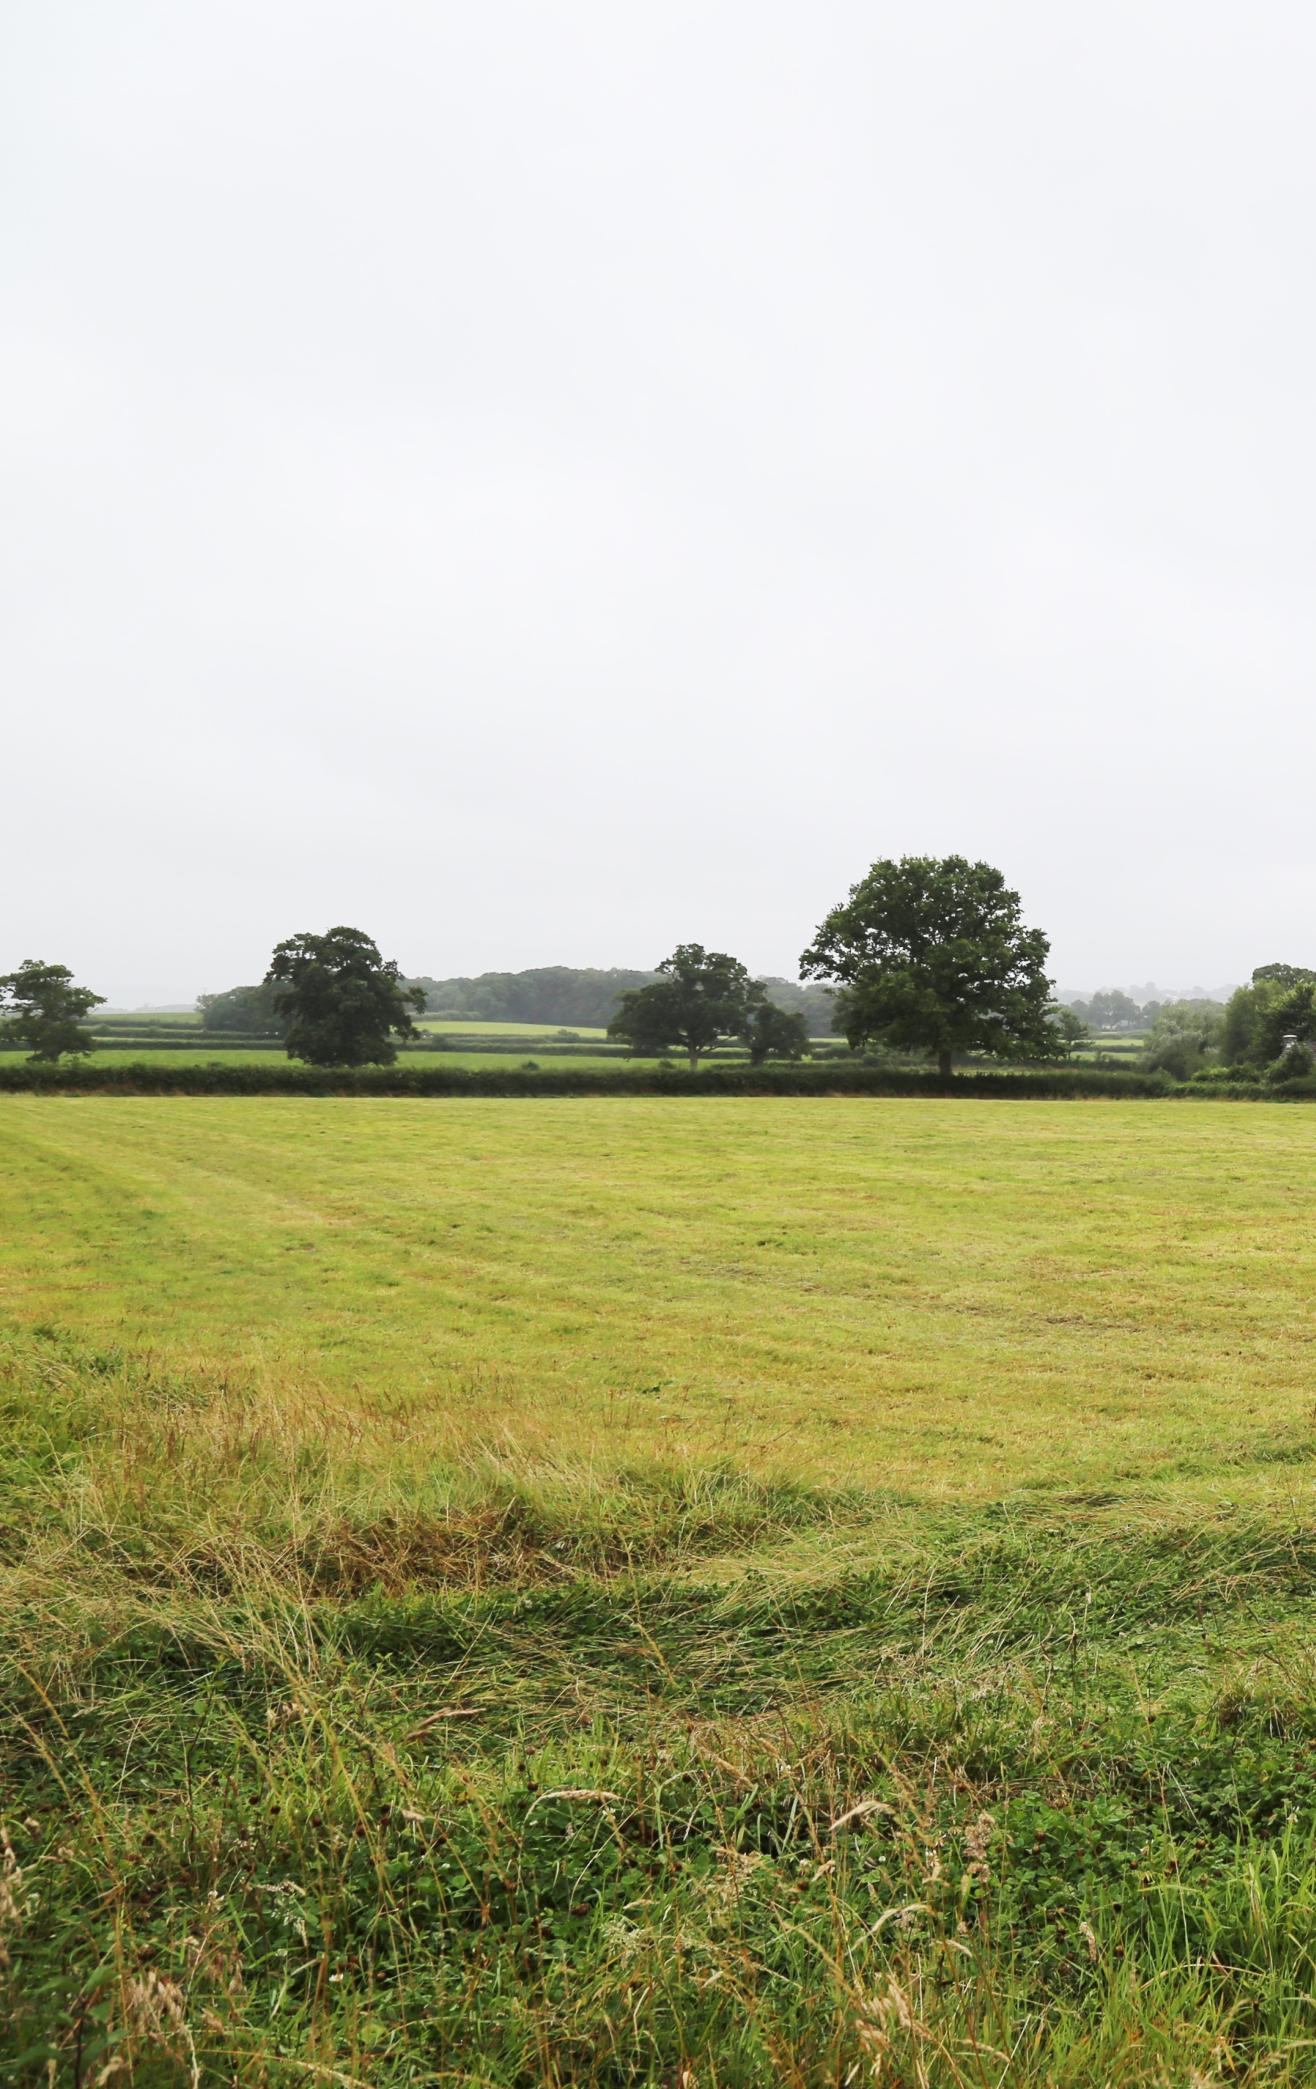

Holwell Neighbourhood Planning Design Guidelines
March 2018



Quality information
Prepared by |  | Checked by |  | Approved by
Name  Emma van der Velde  Landscape Architect  AECOM |  | Name  Jon Rooney  Technical Director  AECOM |  | Name  Adam King  Associate Director  AECOM
Revision History
Revision | Revision date | Details | Name | Position

Prepared for:
Locality

Prepared by:

‌
AECOM
1 Wellbrook Court,
Girton,
Cambridge,
CB3 0NA,
United Kingdom

T: +44 1223 488 000
aecom.com

© 2018 AECOM Limited. All Rights Reserved.
This document has been prepared by AECOM Limited (“AECOM”) for use of Locality (the “Client”) in accordance with generally accepted consultancy principles, the budget for fees and the terms of reference agreed between AECOM and the Client. Any information provided by third parties and referred to herein has not been checked or verified by AECOM, unless otherwise expressly stated in the document. No third party may rely upon this document without the prior and express written agreement of AECOM.
Where the conclusions and recommendations contained in this Report are based upon information provided by others it is upon the assumption that all relevant information has been provided by those parties from whom it has been requested and that such information is accurate. Information obtained by AECOM has not been independently verified by AECOM, unless otherwise stated in the Report. The methodology adopted and the sources of information used by AECOM in providing its services are outlined in this Report. The work described in this Report was undertaken in the period May 2017 to February 2018 and is based on the conditions encountered and the information available during the said period of time. The scope of this Report and the services are accordingly factually limited by these circumstances.
Where assessments of works or costs identified in this Report are made, such assessments are based upon the information available at the time and where appropriate are subject to further investigations or information which may become available. AECOM disclaim any undertaking or obligation to advise any person of any change in any matter affecting the Report, which may come or be brought to AECOM’s attention after the date of the Report.
Certain statements made in the Report that are not historical facts may constitute estimates, projections or other forward-looking statements and even though they are based on reasonable assumptions as of the date of the Report, such forward-looking statements by their nature involve risks and uncertainties that could cause actual results to differ materially from the results predicted. AECOM specifically does not guarantee or warrant any estimate or projections contained in this Report.
Where field investigations are carried out, these have been restricted to a level of detail required to meet the stated objectives of the services. The results of any measurements taken may vary spatially or with time and further confirmatory measurements should be made after any significant delay in issuing this Report.
Copyright
© 2018 AECOM Limited. All Rights Reserved.

Table of Contents
1. Introduction 5
1.1 The purpose of the document 5
1.2 Planning guidance 7
2. Design Guidelines 8
2.1 Introduction 8
2.2 Street Scene 8
2.3 Urban structure and built form 11
2.4 Restorations and Conversions 14
2.5 Materials and Detailing 15
2.6 Public realm, gardens and vegetation 16
3. Design Palettes 18
3.1 Materials Palettes 18
3.2 Details Palettes 19
3.3 Restoration precedents 21
4. References 22

Figures
Figure 1 Location and context 6

Introduction

The purpose of the document
The design guidelines set out in this document have been developed to support the Holwell Neighbourhood Plan, which is being prepared by the Holwell Neighbourhood Plan working group. The working group recognises that the area (see Figure 1) is likely to evolve over time as a result of changes to the climate, alterations to existing buildings, the occasional introduction of new buildings, and careful and positive changes to the streetscape and public realm. However, certain aspects of the area are sensitive and successive individual changes may cumulatively erode its character.
The Howell Heritage and Character Assessment (HCA) prepared to support the neighbourhood plan proposed the following character management principles for the development of Holwell:
- Retain and protect the rural, tranquil character and scenic beauty of the area;
- The design of new buildings should respond to the scale, density and position of existing buildings in relation to the streets and plots and should enhance local distinctiveness without limiting originality and innovation;
- Development proposals that would result in the loss of trees or woodland should provide a clear commitment to replace this vegetation;
- Conserve and protect heritage assets and their settings;
- Conserve the rural character of roads by maintaining grass verges and hedgerows;
- Where new domestic access points are required, small-scale features such as fencing, entrance gates and hedgerows should respond to the local vernacular to promote and enhance local distinctiveness;
- Proposals to alter historic buildings should demonstrate a thorough understanding of the history and design qualities of the buildings and provide a clear rationale for how this has been taken into account in the design of the proposed alterations, without limiting originality and innovation;
- Improve the quality of community and retail facilities to enhance the sense of place; and
- Proposals that provide designated recreation space and opportunities for play will be encouraged.
The National Planning Policy Framework (NPPF) encourages local authorities to consider using design codes or in this case guidelines to help deliver high quality outcomes for new development. It is important however, that guidance finds the balance between promoting and reinforcing local distinctiveness and allowing for innovation and originality. The NPPF suggests that guidance should focus on the overall scale, density, massing, height, landscape, layout, materials and access of new development in relation to neighbouring buildings and the local area more generally’(NPPF,2012), rather than imposing particular styles or tastes.
The NPPF also emphasises that although the visual appearance and the architecture of individual buildings are very important factors, ‘securing high quality and inclusive design goes beyond aesthetic considerations’ (DCLG, 2012). It is therefore important that planning policies and decisions should address the connection between people and places and how any new development will integrate successfully into the ‘natural, built and historic environment’ (DCLG, 2012).
Holwell has many positive aspects that contribute to its rural character, which should be sustained, reinforced and enhanced. The general design guidelines set out here build on those set out in the HCA and are intended to support and guide positive change across the area, to contribute to and reinforce local distinctiveness.
Each site will have specific strengths, weaknesses, opportunities and challenges that should be understood and addressed through design. The structure of these design guidelines are intended to be flexible such that other building types and design principles for specific areas or site allocations may be developed in the future. They are intended to guide developers and home owners to help them understand how to apply the policies set out in the Holwell Neighbourhood Plan with respect to the design, layout, materials and landscape in the preparation of planning applications.

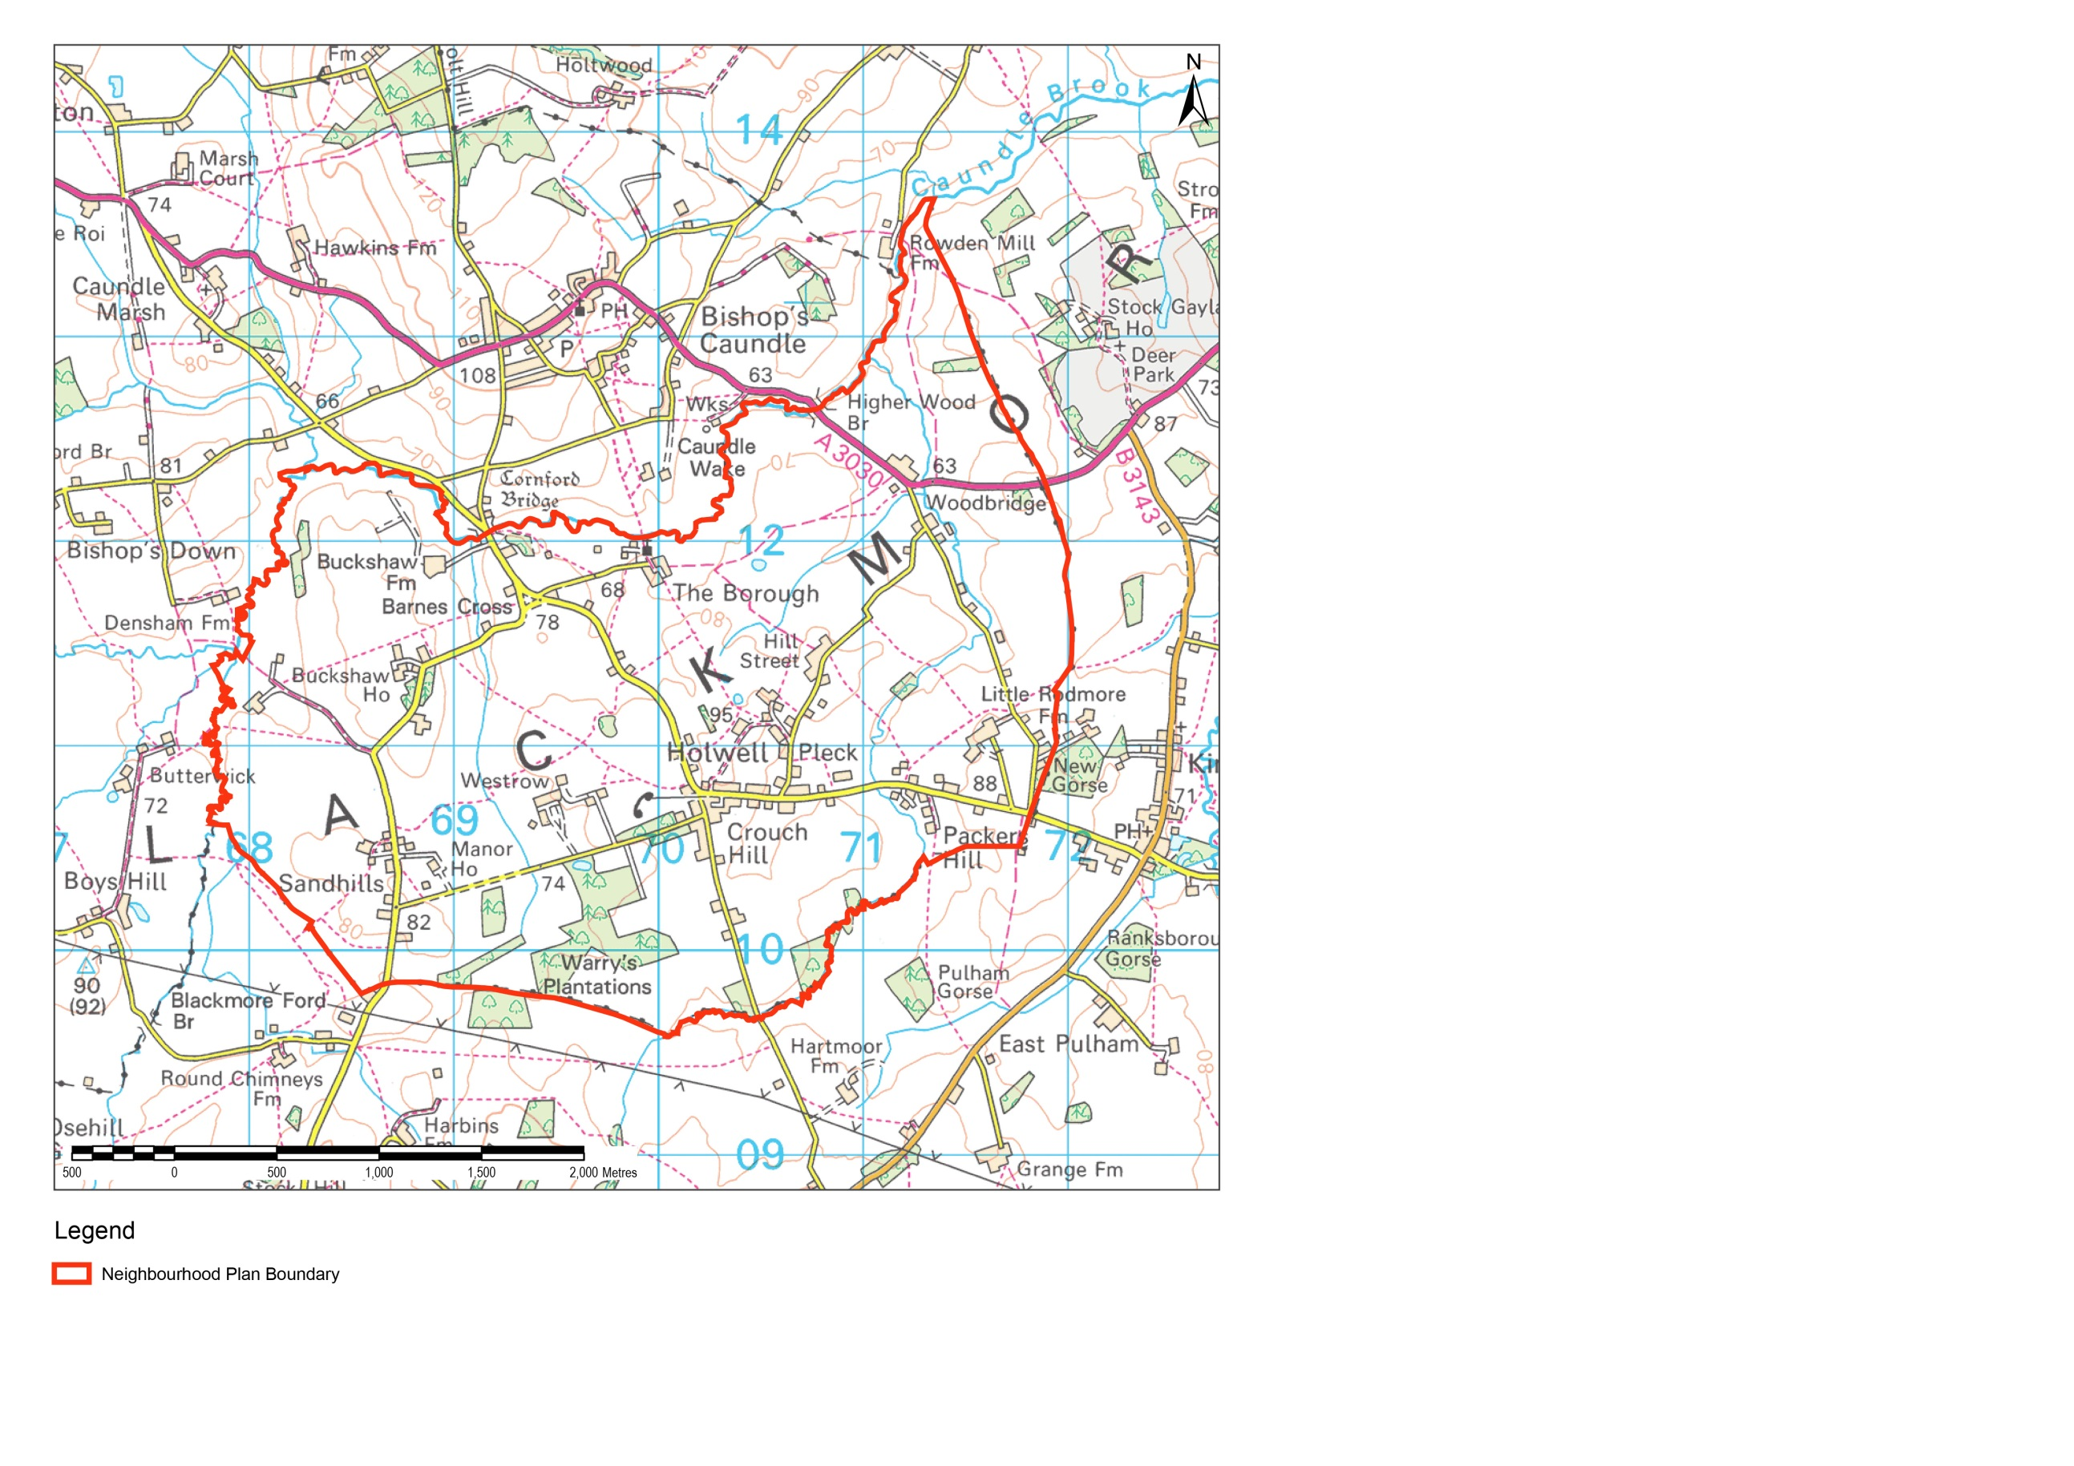
Contains OS data © Crown copyright and database right 2017

Figure 1 Location and context

Planning guidance
The requirements of these design guidelines are additional to all other relevant statutory planning policy and guidance. This document should be read in conjunction with relevant national, regional and local planning policy and supplementary documents and guidance, including:
- National Planning Policy Framework, 2012;
- West Dorset, Weymouth and Portland Local Plan, 2015;
- West Dorset Design and Sustainable Development Planning Guidelines, 2009;
- West Dorset Planning Obligations Guideline, 2009;
- West Dorset Landscape Character Assessment, 2009; and
- West Dorset Weymouth and Portland Sustainability Appraisal, 2015.

Design Guidelines

Introduction
Holwell is a dispersed settlement concentrated mainly along Crouch Lane, Fosters Hill and Pulham Road. The village comprises low-density development of predominantly detached houses set in large plots, characteristic of the rural area. This is further enhanced by extensive mature gardens which surround most properties. The following guidelines apply:

Street Scene

Aspect | What we are looking for | What good design looks like / criteria?
Building line | The set back of new buildings should respect the existing building line along the street | Measured from the back of the carriageway to the front elevation.
Infill | In rural locations, infill plots can alter the character of a village if not carefully designed. | Infill development can be integrated provided the design and layout of the new buildings respect the traditional street scene and character of the village.
Replacement dwellings | In rural locations, replacement dwellings can alter the character of a village if not carefully designed. | Care should be taken to ensure:  - The scale of development is in keeping with the street and appropriate to the size of the plot.  - There is a positive relationship between the building and the street.  - Reference should be taken from the local vernacular to determine the most appropriate proportions for the replacement dwelling.
Density | Like for like replacement or low density as appropriate | Single conversions or replacements. In exceptional cases, it may be appropriate to replace with a small group of dwellings - each assessed individually.  Development could also be built to look like a single larger building which is then subdivided.
Permeability | Small scale developments that enhances permeability through the settlement, incorporate enhancements to the public realm or provide communal green space should be encouraged. | Create pedestrian and cycle friendly environments to reduce the need to travel by car.
Boundary treatment | Where development affects the boundaries of a property, new development should consider boundary treatments which are common or complimentary to the street. | In Holwell boundary treatments such as stone walls, timber fences and vegetated hedgerows are common. Modern materials that complement the street scene will also be encouraged provided they are in context with the local vernacular.  See Image 1
Materials | Materials used in new development should complement the materials typical of the existing buildings in the street, the streetscape or the existing building in the case of extensions. | Materials that are durable, high quality and easy to maintain are preferable.  See materials palette below.
Architectural quality | Evidence that the design and materials used, the amount and type of decoration and functional elements such as the position and type of doors and windows, flues, chimneys, gutters and flashings has been considered complement the local vernacular | Identify opportunities to make a positive contribution to character. New development that has considered the local context will reinforce and enhance the local identity. See materials and design palettes below.
Green infrastructure | New development should reinforce the well-managed network of grass species rich verges, hedgerows and woodland lining the routes through the area, which are characteristic of the rural landscape. | In Holwell the rural landscape is the dominant feature; the buildings secondary. Vegetation can be used to blend buildings into their surroundings and draw the rural landscape into the settlement.
Trees | Where new development is proposed, there should be no net loss of trees and at least two trees shall be planted for each tree lost. | Native trees and shrubs should be planted wherever possible as they are locally appropriate and draw the rural landscape into the settlement.
Front gardens | Proposals which affect the front of properties shall be accompanied by detailed plans which show a commitment to retaining and enhancing attractive, well-vegetated gardens. | Vegetation planting in private front gardens should be in informal to complement the rural context of the settlement.  Vegetation and trees should be retained or proposed to screen bins or cycle stores in view of the street.
Parking | The design of parking areas should be appropriate to the scale and location of the residential development. | Parking areas should be surfaced using a permeable material to provide adequate natural drainage.
Street furniture | Street furniture such as benches and bins required for public realm should complement the local vernacular. | Design and location should be carefully considered. Seating areas encourage people to gather and as a result should provide adequate space.
Views | Developments should make the most of existing features and views and new development that complements the rural setting of Holwell should be encouraged. | Retain the gaps between existing buildings and provide gaps in new development to secure through views towards the rural landscape.

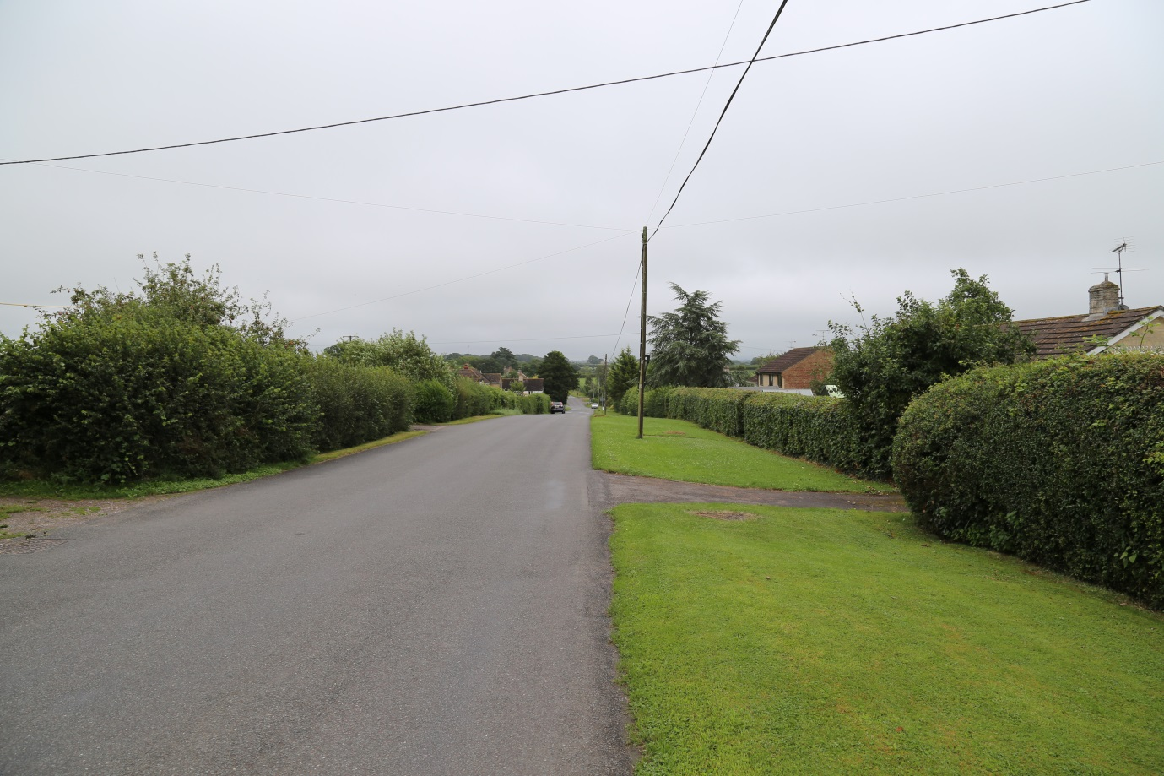
Image 1: Fosters Hill: the main residential street in Holwell.
EXISTING PROPERTIES SET BACK BEHIND WELL VEGETATED FRONT GARDENS
WIDE VERGE BETWEEN PROPERTIES AND THE STREET
DENSE HEDGEROW ON PROPERTY BOUNDARIES
VIEWS TO A DISTANT HORIZON

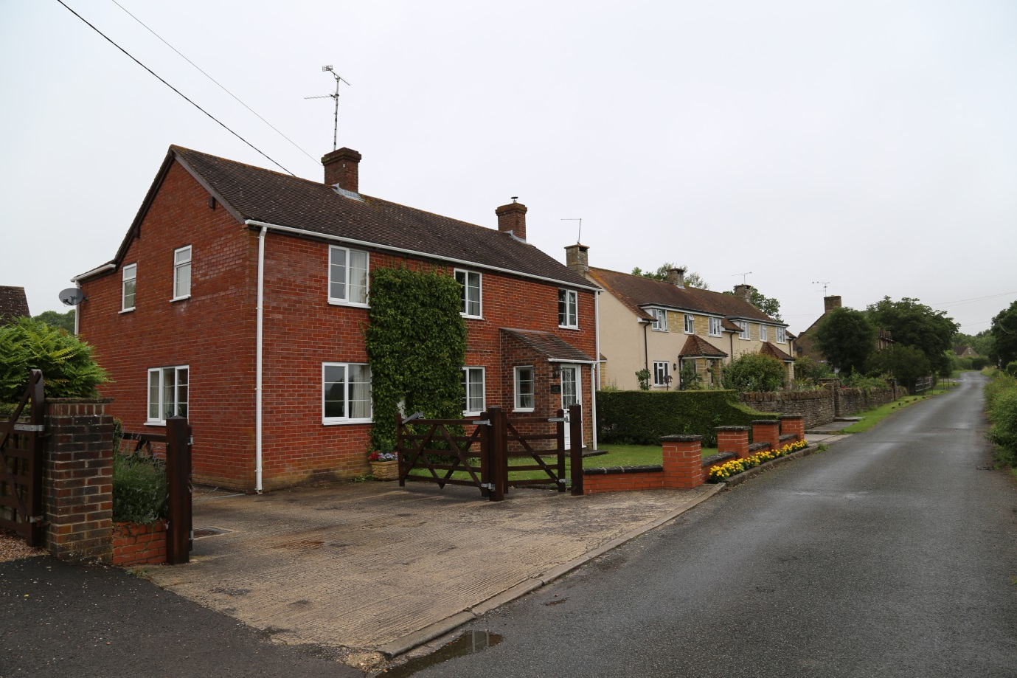
NEW PROPERTY SET BACK FROM STREET RESPECTS THE POSITION OF EXISTING PROPERTIES
Image 2: Peaceful Lane

Urban structure and built form
Aspect | What we are looking for | What good design looks like / criteria?
Scale, height, massing | New development will be more likely to integrate successfully with the settlement if the scale, height and massing of new buildings demonstrates consideration for the context of the original buildings within the area. | Buildings should not be designed in isolation. Whether they are of traditional or contemporary design, buildings should be part of a design concept for the whole site. This will need to be explained in a Design and Access Statement accompanying the planning application.
Height and roofline | New houses that respect the existing height and follow the roofline of adjacent houses should be encouraged. Similarly proposed extensions are more likely to be successful if they do not exceed the height or footprint of the original building. | Roofs should be designed to reflect the style of the proposed development and its context. Careful attention should be paid to roofing materials, pitch, eaves and verge details and the inclusion of chimney stacks or other features that project above the ridge line. In general, a simple roof form is preferred. See Image 3
Position | New development and alterations to existing buildings, shall respect the position of existing buildings relative to the street and within the plot. | The proportions of proposed houses should match adjacent houses of the same building type.
Building lines | New development or building extensions shall respect the existing building lines. Existing front gardens should be retained to ensure a green setting to the building, enhance the public realm and provide a suitable buffer between the built form and the surrounding rural setting of Holwell. | See Image 5
Storage | Provide secure storage for cycling equipment. | Cycle and bin stores should be integrated into the garden and screened from the street.
Windows | Windows in new houses should complement the vertical pattern and scale of windows reflected in local architectural detailing. | Use windows as part of the overall design approach. In more traditional designs, the positioning of windows within their reveals is important to add visual interest.  See details palettes below.
Window paint |  | The choice of paint colour for windows can have a dramatic effect on the appearance of a building. Paint colours should respect traditional, local colours. For Holwell muted, natural tones are appropriate. See materials and design palettes below
Doors | Doors can be noticeable features and, as with windows, they can have a dramatic impact on the appearance of a property. | Use doors that reflect the design approach see design palette below. Doors should be simple and well-proportioned; pastiche of historical designs should be avoided.
Detailing | Architectural detailing in new development shall typically display elements that balance with those on existing traditional buildings in terms of interest, scale and texture and form. | Traditional elements often include detailing around windows including cills, quoins and masonry detailing, door surrounds or porches and timber framed, sash windows. Attention to high quality architecture and architectural detailing which avoids pastiche is encouraged. See details palette below.
Detailing | Existing period detailing should be retained and the covering over or removal of such elements is not encouraged. | The inclusion of details should be undertaken with care as overly detailed elevations can appear fussy and historic detailing can appear like a caricature of the original. See materials and details palettes below.
Quality | Architectural detailing is rich with a variety of different styles and decoration used in buildings across the area; the design of extensions and new buildings should reflect this level of detailing to ensure that the development is in context with its surroundings. | See details palette below.
Frontages | New building frontages should propose a level of detail based on the detail used on existing original buildings within the area. Where period details are proposed it is advised they are based on a local historical precedent. | See materials and details palettes below.  Porches are a common in Holwell. Use porches that reflect the design approach.
Materials | Use locally appropriate materials. Materials proposed for the use in building extensions shall compliment those used in the existing building. A typical palette in Holwell includes rubble stone, red stock bricks, timber painted windows, clay and slate roof tiles, external porches and door and window surrounds. | Historically, the choice of wall materials in Holwell was largely dictated by those materials that could be sourced locally, and this largely comprised brick and stone for walls. In more recent times the range of materials has broadened. The material palette illustrates some of the materials used across the Parish.
Materials | Materials used for the repair or alteration of buildings, for new buildings, and for surfacing and boundaries shall complement the existing high quality palette of materials that typifies the character of the area. | See materials palette below.
Materials | New buildings or extensions should propose materials based on the existing building or surrounding vernacular. Proposals for innovative and complementary material options should also be encouraged. | Differing materials on an extension or a different design approach may result in a development appearing incongruous. Whilst, exceptionally, an extension may intentionally be designed to be contrasting, such an approach will need to be carefully justified and its success will rely on a high quality design.
Natural Surveillance | Natural surveillance takes place when people can see what is happening where they live. Crime rates are less in locations where people believe they are being watched. | Maximise opportunities for communities to become self-policing

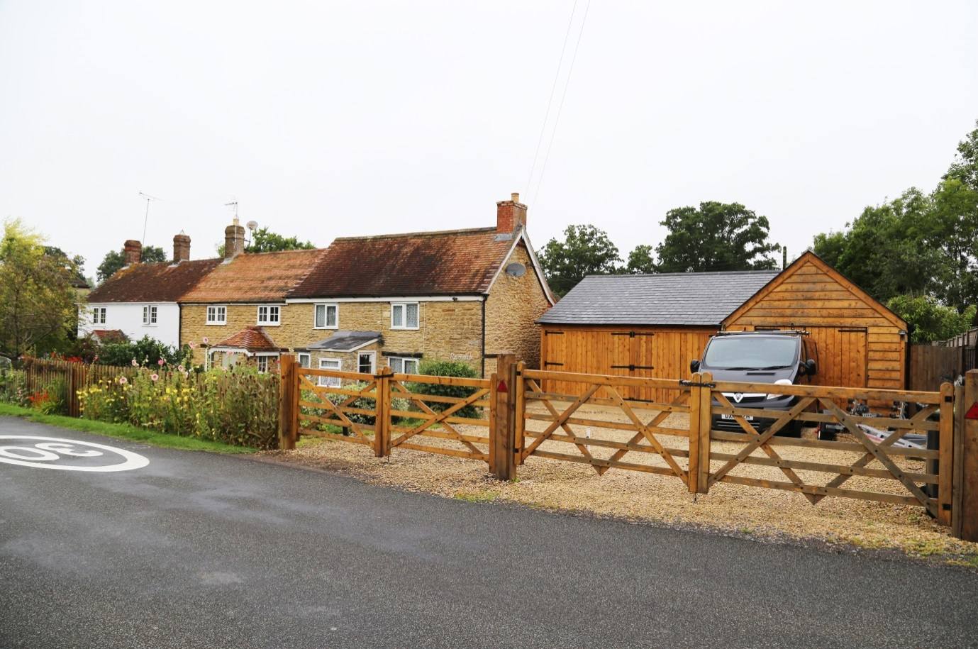
NEW PROPERTY RESPECTS ROOFLINE OF EXISTING PROPERTIES
EXISTING PROPERTIES
Image 3: Cottages, Fosters Hill

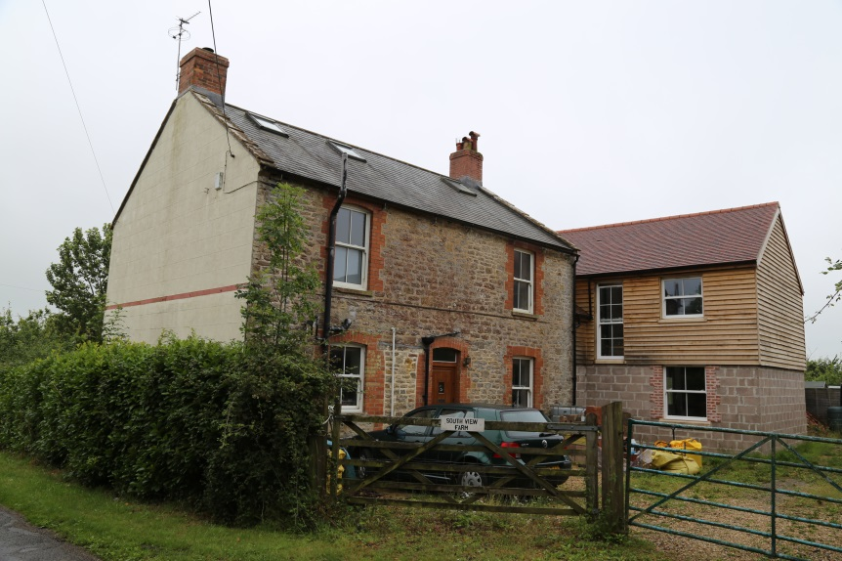
Image 4: Extended property, Crouch Lane
NEW EXTENSION RESPECTS SCALE, PROPORTIONS AND ROOFLINE OF EXISTING PROPERTY.

WINDOWS ON NEW EXTENSION HAVE BEEN DESIGNED TO COMPLIMENT THE EXISTING WINDOWS

Restorations and Conversions
Aspect | What we are looking for | What good design looks like / criteria?
Restoration | Restoration of existing buildings in the Conservation Area is preferable to the demolition and replacement of buildings. | See Image 6
Restoration | Where buildings are modernised, it is advised existing proportions of doors and windows should be considered. | Use appropriate materials and techniques for extensions.  A mix of modern and traditional materials particularly within a timber frame building can be appropriate and allows for greater innovation in design.  See Image 6
Extensions/conversions to agricultural buildings | Agricultural buildings contribute to the rural setting, the character and appearance of Holwell and conversions to these buildings should reference age, design, form, materials used, roof structure and the presence of any architectural detailing. | The introduction of conspicuous domestic features and additional window or door openings tend to be out of character.  Retention of exiting features and a simple design approach is usually most appropriate.  Large extensions or ancillary buildings are not usually appropriate for conversions. Landscaping and boundary treatments need careful attention and should be designed to be as informal and simple as possible.
Conversions of chapels, churches and schools | Holwell has numerous civic buildings. The potential future change of use and conversion of these buildings should ensure their defining characteristics are retained and enhanced. | Compromises to residential provision may be required to retain characteristic features.  The introduction of conspicuous domestic features, additional window or door openings tend to be out character. Existing window openings, window detailing’s and ecclesiastical features should be retained and refurbished. Pastiche should be avoided.  Additional floors should not visibly cut across tall windows.  Large extensions or ancillary buildings can dominate the original building and so detract from its character.  Landscaping and boundary treatments should be designed to be as simple as possible.
Garages and Outbuildings | Garages, cycle stores and bin stores are a feature of modern living, and should be included as an integral part of the overall design from the outset. | Design outbuildings to be subordinate to the dwellings.

Public realm, gardens and vegetation
Public green space in Holwell is limited, therefore private gardens, mature trees, Public Rights of Way (PRoW) and other open space form the “green infrastructure” of the area and contribute to the overall openness and rural setting. Front gardens contribute strongly to the character of each street and provide the setting to each building. Gardens create space between and around buildings allowing views across the area and beyond to the rural landscape. The following principles apply:
Aspect | What we are looking for | What good design looks like / criteria?
Gardens | Gardens and the mature vegetation within them should be retained to ensure that each building has an attractive, verdant setting. | Front gardens should be provided with lawns, tree planting, hedges and only small areas of hard surfacing either aggregate or paving. Where hard-surfacing for car parking in front gardens is necessary, it should be screened from view of the street by trees and hedge planting.
Tree | Mature trees should be retained or where lost to development replaced. | Retention of all trees and hedgerows, especially along property boundaries is vital. If trees and hedges do need to be removed, they should be replaced within the site.
Public realm | Public realm or communal green space should be provided in development plots to contribute to the provision or enhancement of green space in the area. | Avoid open spaces that lack character or purpose  Identify opportunities to make a positive contribution to character

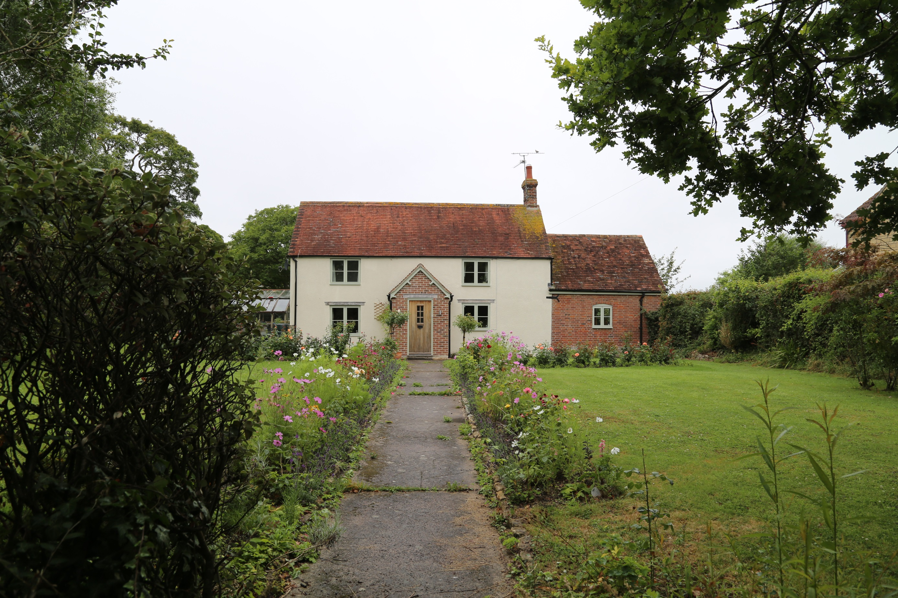
Image 5: Restored property,
Crouch Lane

COTTAGE GARDEN PLANTING COMPLEMENTS THE RURAL SETTING
LARGE FRONT GARDENS PROVIDES AN ATTRACTIVE SETTING FOR RESIDENTIAL PROPERTIES, CHARACTERISTIC OF A RURAL SETTLEMENT

Materials and Detailing
The materials and architectural detailing used throughout Howell contribute to the rural character of the area and the local vernacular. It is therefore important that the materials used in proposed development are of a high quality and reinforce the local distinctiveness of the area. Development proposals should demonstrate that the palette of materials has been selected based on an understanding of the surrounding built environment.
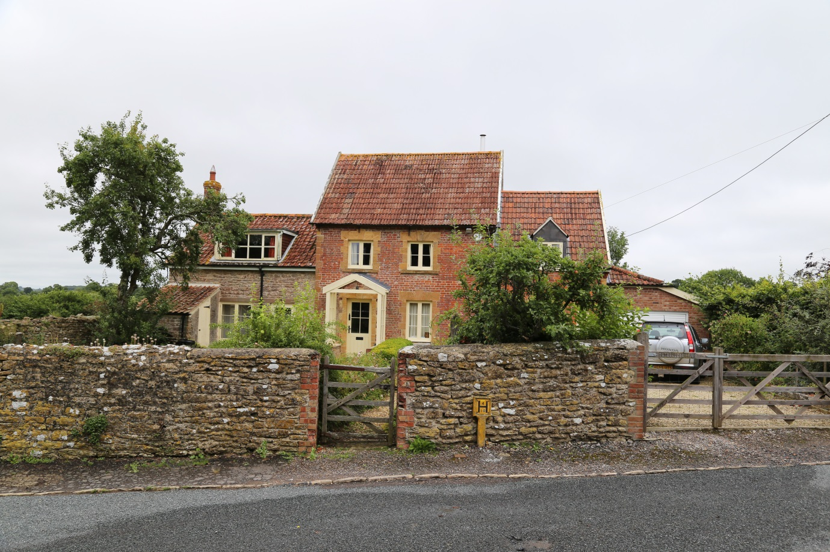
SMALL DORMER WINDOW
MODERN EXTENSION IN SCALE WITH ORIGINAL PROPERTY
RUBBLE
STONE BOUNDARY
QUOIN MASONRY DETAILING
VEGETATED FRONT GARDEN
TIMBER GATE
RED CLAY ROOF TILE
MASONRY DETAIL ABOVE WINDOWS
Image 6: Detached property, Conservation area
EXTERNAL PORCH

Design Palettes

Materials Palettes

Below are examples of building material that contribute to the local vernacular of Holwell and could be used to inform future development. It should be noted that these materials are not prescriptive and there is opportunity for innovative and creative material suggestions in new buildings, restorations and extensions that may compliment what already exists.

Details Palettes
Below are examples of architectural details that contribute to the local vernacular of Holwell and could be used to inform future development. It should be noted that these materials are not prescriptive and there is opportunity for innovative and creative architectural designs in new buildings, restorations and extensions that may compliment what already exists.

Windows/Chimneys/Additional Features

Masonry Detailing/Porches

Restoration precedents
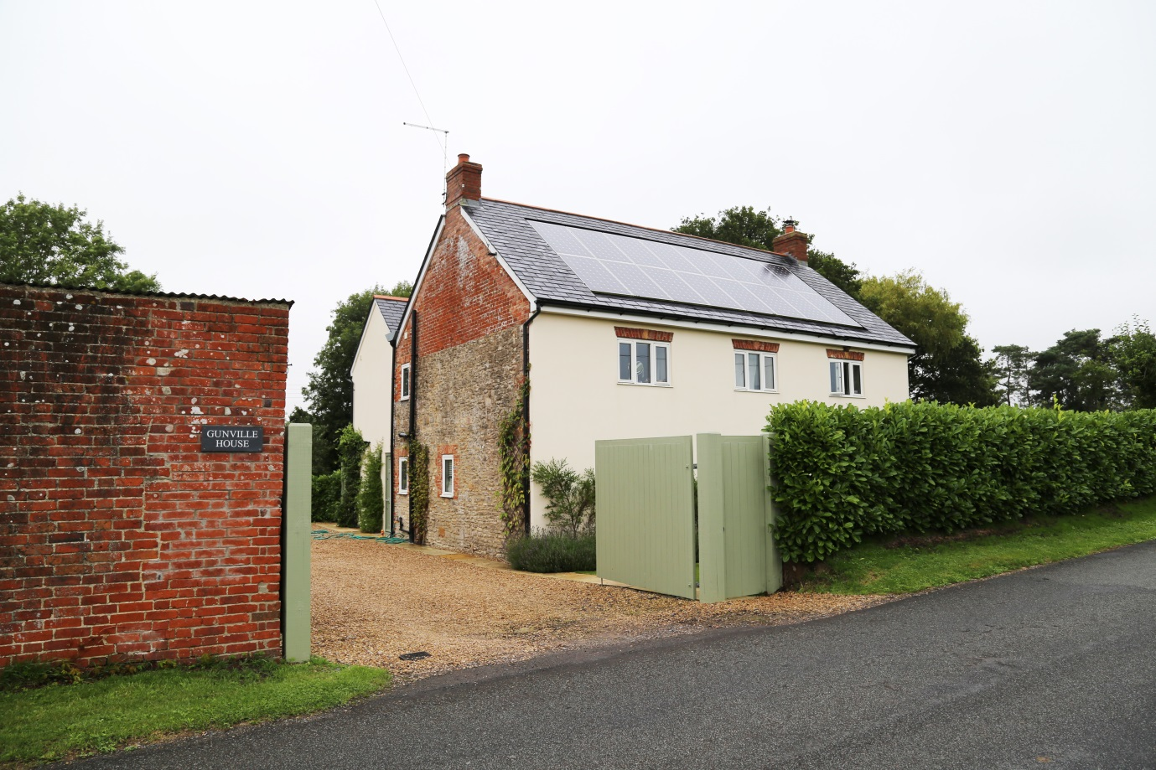
Restored property, Foster’s Hill:

- Masonry detailing above windows
- Mix of facades, render and brick
- Mix of boundary solutions in keeping with the local vernacular, dense hedge, painted timber doors natural timber and red brick.

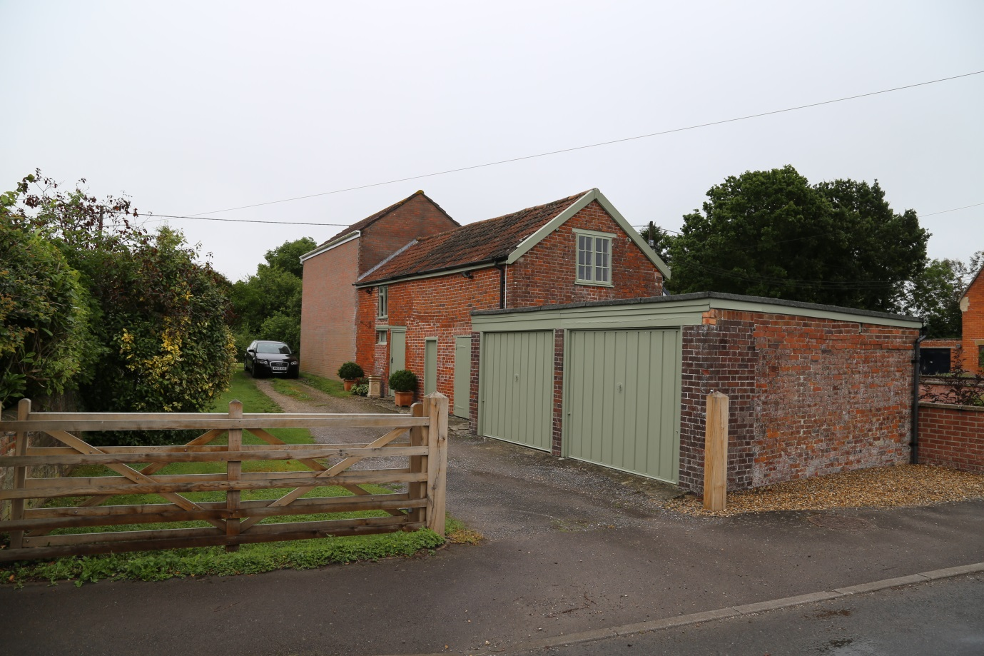
Restored property and outbuilding, Foster’s Hill:

- Painted timber with red brick
- Timber gate

References
Department of Communities and Local Government. (2012) National Planning Policy Framework. [online] Available: <https://www.gov.uk/government/publications/national-planning-policy-framework--2>. Last accessed 1 February 2018

West Dorset District Council, Weymouth and Portland Borough Council (2015) West Dorset, Weymouth and Portland Local Plan. Available: https://www.dorsetforyou.gov.uk/media/209581/West-Dorset-Weymouth--Portland-Local-Plan-2015/pdf/West_Dorset__Weymouth___Portland_Local_Plan_2015.pdf. Last accessed on 1 February 2018

West Dorset District Council (2009) Design and Sustainable Development Planning Guidelines. Available: https://www.dorsetforyou.gov.uk/media/135106/Supplementary-Planning-Document-February-2009/pdf/JW_pb_Design_SPD_090320.pdf. Last accessed on 1 February 2018.

West Dorset District Council (2009) Planning Obligations Guideline. Available: https://www.dorsetforyou.gov.uk/media/143235/Planning-Obligation-guidelines/pdf/Planning_obligations_guidelines_web_version.pdf. Last accessed on 1 February 2018

West Dorset District Council (2009) West Dorset Landscape Character Assessment. Available:https://www.dorsetforyou.gov.uk/media/pdf/m/r/Landscape_Character_Assessment_February_2009.pdf. Last accessed on 1 February 2018

West Dorset District Council, Weymouth and Portland Borough Council (2015) Sustainability Appraisal. Available:https://www.dorsetforyou.gov.uk/media/209520/SustainabilityAppraisal/pdf/FORMATTED_OR_fn_Sustainability_Appraisal_WEB.pdf. Last accessed on 1 February 2018

aecom.com

