APPENDIX I – FOOTPATHS BRIDLEWAYS AND RIGHTS OF WAY IN HOLWELL

367₀₀₀
368₀₀₀
369₀₀₀
370₀₀₀
371₀₀₀
372₀₀₀
373₀₀₀

Footpaths
113₀₀₀
© Dorset County Council 2018. Contains Ordnance Survey Data. Crown Copyright and Database Right 2018. The Rights of Way depicted on this plan show the approximate routes only. For any legal purpose please refer to the Definitive Map. This is kept at County Hall and can be viewed by appointment during office hours., ©, Crown copyright [and database rights] 2018 OS LA100019790. Use of this data is subject to terms and conditions. This map is

Centre Easting: 370055.85
Centre Northing: 111688.41
Zoom: 6188.139m (14)
Date: 14/03/2018
113₀₀₀

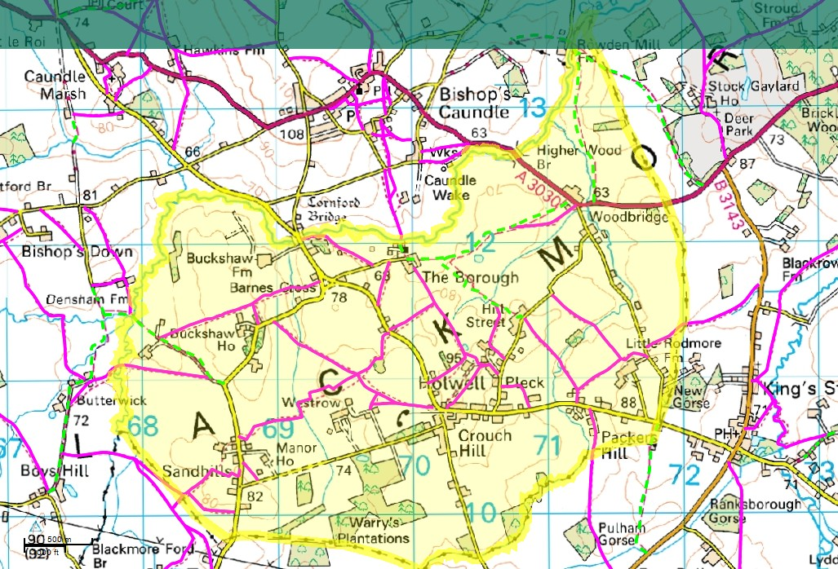

367₀₀₀
112₀₀₀
111₀₀₀
110₀₀₀
110₀₀₀
111₀₀₀
112₀₀₀
368₀₀₀
369₀₀₀
370₀₀₀
371₀₀₀
372₀₀₀
373₀₀₀

