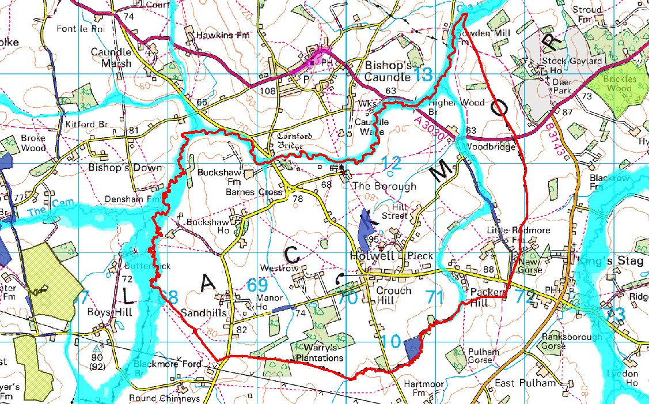
APPENDIX J - EXTRACT FROM STRATEGIC ENVIRONMENTAL ASEESSMENT SCREENING DOCUMENT

Figure 3.1: Environmental designations within the Holwell Neighbourhood Plan area
© Crown Copyright and database right (2017). Ordnance Survey Licence number 100024307. © and Database rights Environment Agency 2016. All rights reserved. Some of the information within the Flood Map is based in part on digital spatial data licensed from the Centre for Ecology and Hydrology © NERC. © Historic England 2016. © Crown Copyright. All rights reserved 2016
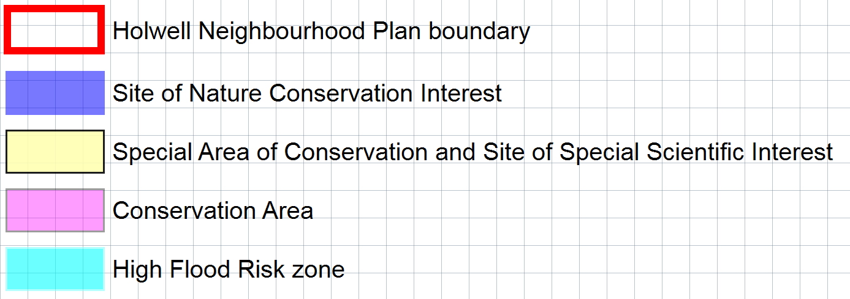
Legend

