APPENDIX L ECOLOGY NETWORK MAP

368₀₀₀
369₀₀₀
370₀₀₀
371₀₀₀
372₀₀₀
373₀₀₀

Ecology Network
Dorset Explorer January 2018
©, Crown copyright [and database rights] 2018 OS LA100019790. Use of this data is subject to terms and conditions., © Dorset County Council 2018 This map is not definitive and has no legal status.

Centre Easting: 370190.80
Centre Northing: 111495.39
Zoom: 6188.368m (14)
Date: 05/01/2018
113₀₀₀

KEY
Lighter green (all outside parish) = designated Sites of Special Scientific Interest
Green = part of locally identified network (SNCIs as shown on the SEA screening with some minor changes including an additional area around Barnes Cross)
Triangle = recorded veteran trees

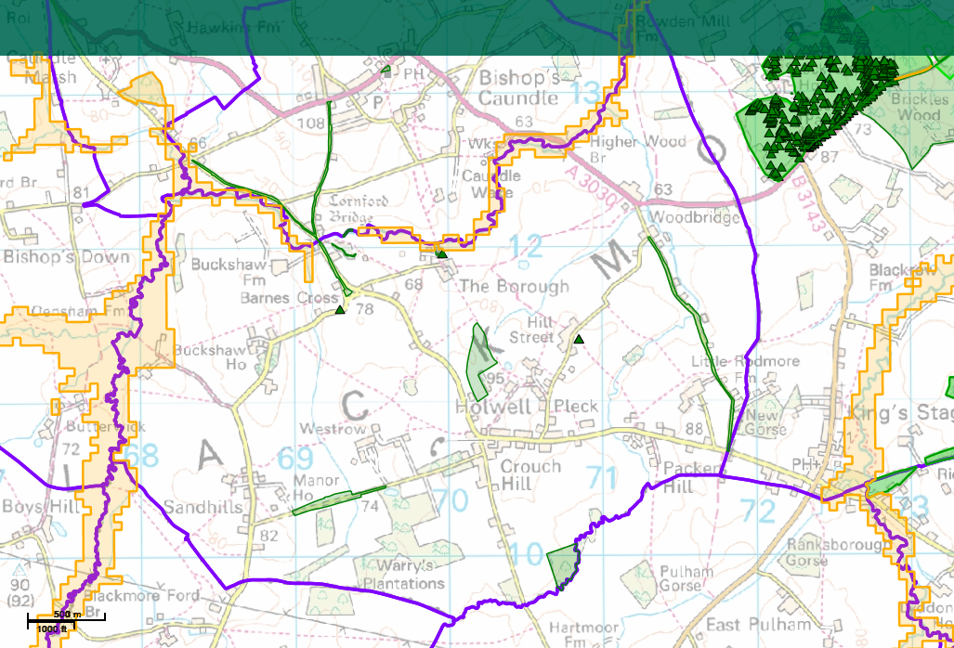

368₀₀₀
112₀₀₀
111₀₀₀
110₀₀₀
110₀₀₀
111₀₀₀
112₀₀₀
113₀₀₀
369₀₀₀
370₀₀₀
371₀₀₀
372₀₀₀

