Meeting | 1
Meeting title: | Neighbourhood Plan Working Group
Date: | 6th February 2013
Venue: | Peveril House, Holwell
Attendees: | Neil Peirson (Chair Holwell PC)  Bruce Duncan (Chair Holwell NP Working Group)  Rodney Antell  Steve Atchison  Patrick Constable  Sue Crosby  Phil Curtiss  Jo Edmondson  Colin Evans  Robert Hole  Dave Hollex  Peter Macfarlane |  | NP  BD  RA  SA  PaC  SC  PhC  JE  CE  RH  DH  PM
 | Apologies for absence: Bob Pearce
Agenda: | - Purpose and Introductions  - Admin – List of e-mail addresses and phone numbers  - Secretary and Target Co-ordinators  - Facts  - Plans (Map) and West Dorset DC Local Planning Authority  - Learning About Neighbourhood Plans (NPs)  - Project Timetable – Plan and Fitness Planner  - The Five Focus Groups  - Holwell Parish Council (HPC) Website update  - Communication between NP members between meetings  - AOB & Date of Next Meeting

 |  | Actions
1. | Purpose and Introductions
The meeting was opened by NP, as chair of the Holwell Parish Council.
All those present said who they are and where in the village they live.
NP gave a brief explanation of the purpose of the meeting: to discuss the way ahead for producing a Neighbourhood Plan that will establish planning guidelines for the local authority to use when considering future planning applications in the village.
NP also briefly explained the process, leading from the development of the Neighbourhood Plan to discussions with the local planning authority and review by planning inspectors, before a referendum is held on whether to approve the plan or not.
Copies of the presentation given at the meeting on 2nd October 2012 by Jo Witherden were provided by NP, and soft (electronic) copies would also be made available.
2. | Admin – List of e-mail Addresses and Phone Numbers
E-mails and phone numbers had been provided before the meeting; all but one of those present could be contacted by e-mail.
NP then proposed handing over chairmanship of the meeting to BD. This was agreed.
Copies of the following were provided (see attachments):
- Attachment 1 - General Notes for Meeting 1 (1 sheet).
- Attachment 2 - List of 5 Focus Groups (1 sheet).
- Attachment 3 - “Ourtown Neighbourhood Plan Project Plan” (on 2 sheets).
- Attachment 4 - “Brief Guide to Completing a Project Timetable” (1 sheet).
- Attachment 5 - “Neighbourhood Planning: Preparation Fitness Planner” (1 sheet).
3. | Secretary and Target Co-ordinators
BD explained that the group would need one or possibly two secretaries. The aim would be to develop a dossier.
BD proposed that we consider five key areas by creating focus groups to look at (see Attachment 2):
- Focus Group 1 - Housing
- Focus Group 2 - Employment and Business
- Focus Group 3 - Roads and Transport
- Focus Group 4 - Environment
- Focus Group 5 - Community
See Section 8 for more on Focus Groups.
4. | Facts
BD explained that, as a first step, the working group would need to collect facts about Holwell, to provide us with a basis for developing the Neighbourhood Plan - see Attachment 1 for a list of some of these.
Some facts about the village were discussed at the meeting.
PhC had studied the 2011 census and said that there are about 160 households in Holwell and that the population is about 369, of which 51 were 16 or under at the time of the census.
BD asked if the population had decreased, increased, or stayed the same since the last census. PhC said that one would need to compare the data from the 2011 census with the 2001 census, but that one would need to allow for changes to the boundary between Holwell and Bishops Caundle – as a result, Bishops Caundle now has a higher population than Holwell.
The question of employment in Holwell was raised. It was believed that about 24 people work at Honeybuns Bakery, of whom 2 live locally.
The number of second homes in Holwell was discussed. CE said that a high percentage of properties are owner occupied. PhC said that this might be gleaned from the census. BD said that the Council Tax register gave this information; he believed that there are 3 second homes in the village at present.
5. | Plans (Map) and West Dorset DC Local Planning Authority
BD displayed a map of Holwell, that had been provided by CE; it may be possible to provide copies of these. BD explained that we should try to designate the boundary of an area within which the Neighbourhood Plan would apply. He added that we should bear in mind that whatever we produce in the Neighbourhood Plan has got to work and so it needs to be viable.
The identification of this area was discussed. BD said that we might, for example, state that we would like x houses built of which y should be affordable properties, though we might also say that there should be no house building within the area. This would not necessarily preclude development outside the area, but that would then not be supported by the village.
DH said that we should be careful not to shut out parts of the village by only considering a given area.
6. | Learning About Neighbourhood Plans (NPs)
BD explained that we would be able to have the help of a support officer from the West Dorset District Council.
PM asked what villages were developing Neighbourhood Plans. NP said that only five other parishes had opted to do this. For example, King’s Stag had decided not to develop a Neighbourhood Plan. PM said that a benefit of having a Neighbourhood Plan would be that it could protect a village from development that might otherwise be forced upon it.
SA asked what the result would be if a Neighbourhood Plan were put forward at a referendum but rejected. BD said that there would then be no Neighbourhood Plan, and the process would be at an end.
BD said that the Neighbourhood Plan would generally be reviewed every 5 years.
7. | Project Timetable – Plan and Fitness Planner
The plan and timescales for developing the Neighbourhood Plan were discussed (see Attachments 3 to 5).
BD’s view was that it would take up to about 9 months to complete, but he pointed out that it is for the village to do, not just this group.
NP added that the only time restriction imposed on us is that there must be a six week consultation period. However, he pointed out that the first Neighbourhood Plan to be developed, for Eden in Cumbria, has taken 2 years. However, this covered 17 parishes (and included aspects like broadband).
8. | The Five Focus Groups
 | BD explained that the five Focus Groups are based on those used by Buckland Newton.  He suggested that each Focus Group should be led by one person, but that it may have two or three people in it, who would then report on progress to the rest of the working group.  The working group was asked to consider which, if any, of the Focus Groups they might like to be involved with and contact NP or BD if interested.  PM asked how we would collect information on villagers’ views. NP said that Buckland Newton had started with a questionnaire and that this would be one way to proceed, although it would require funding and organisation.  Some aspects of the Focus Groups were discussed. | All
8.1 | Housing
Housing was considered to be one of the main concerns in the Neighbourhood Plan, but we need to address the questions of what is wanted - if anything (NP said that the number of houses in the plan could be large or small) and where.
BD pointed out that housing in Holwell was generally cheaper than the equivalent housing in Sherborne, by about 25%. He also said that the Neighbourhood Plan could include preferences concerning the design specification of houses and possibly set a minimum standard.
NP asked if the new houses built in Leigh, at the same time as their new village hall, had been sold. PhC said that builders had put up 2 properties, neither of which had been sold by the summer of 2012.
JE asked what constituted affordable housing. BD explained that affordable units need subsidy and are sold as shared equity or let under Assured Shorthold Tenancy (AST) agreements – the developers receive the rent. He added that 72% of affordable housing never gets built.
The question was raised of whether the affordable housing that had been built recently in Bishops Caundle had been taken.
PhC said that there were currently 8 people on the affordable housing list who had a Holwell connection.

8.2 | Employment and Business
The opportunities for employment in Holwell were discussed. The main sources of employment appeared to be:
- Agriculture
- Holwell Nursery School
- Honeybuns Bakery
8.3 | Roads and Transport
 | The speed and volume of traffic through Howell was discussed. It was generally considered that the volume of traffic had increased over the last ten years. The last speed census identified an average speed of traffic through Holwell, before 8am, of 52mph. Speeds of 85 & 90 mph were recorded in the evening.
8.4 | Environment
 | Environmental issues were not discussed at length although, the possibilities of renewable energy were raised.
8.5 | Community
BD said that the population of Holwell could probably be divided into classes, such as those over 70, those between 60 and 70, the agricultural community, etc..
The need for a village hall was discussed.
PhC said that it is possible to build a village hall by “localism”. He also said that Sherborne Castle Estates had said that they would look favourably on selling the village hall car park to the Holwell Village Hall Trustees, at not much above agricultural land prices.
PhC said that responses to the questionnaire produced at the meeting on 2/10/12 had included the view that the village hall should not be replaced once it was no longer serviceable as Holwell did not necessarily need a village hall.
9. | Holwell Parish Council (HPC) Website Update
 | It was agreed that a website would be necessary for the successful development of the Neighbourhood Plan. BD said that it was hoped that there would be one in about 4 weeks.
10. | Communication Between Working Group Members Between Meetings
 | Most of the working group are accessible by e-mail. BD/NP plan to e-mail everyone with an e-mail address in the next 7 or 8 days. Other arrangements will be made for those without e-mail.
11. | AOB & Date of Next Meeting
11.1 | AOB
There is a Parish Council Meeting on Tuesday 12th February 2013.
PhC said that he had a letter from the owner of land adjacent to Holwell Nursery School stating that he was anxious to put in planning application for building a combination of open market and affordable housing together with an access road. However, PhC felt that this meeting was not appropriate for discussing this further.
11.2 | Date of Next Meeting
Suitable days of the week for future meetings were discussed; there was no day that would be ideal for everybody and it was agreed that meetings should not always be on the same day of the week.
CE asked whether the Neighbourhood Plan meetings would be separate from the Parish Council meetings. BD said that they would be separate, but a report on progress would be included in the Parish Council meeting agenda.
It was agreed that the next full Neighbourhood Plan Working Group meeting should take place after Easter, during April.
BD thanked NP for providing the venue, and refreshments, for this meeting.

Attachment 1:
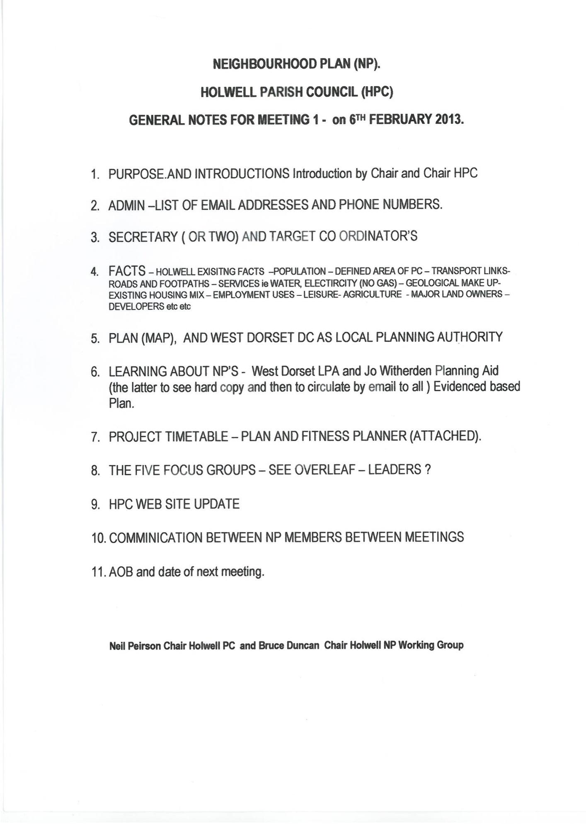
Attachment 2:

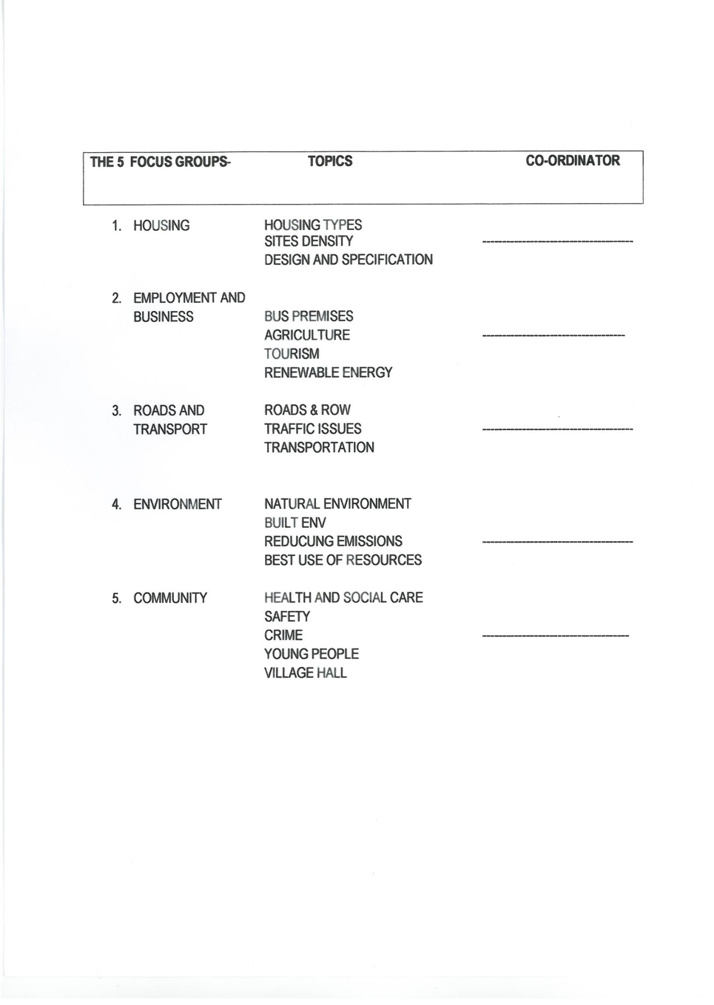
Attachment 3 (Page 1):

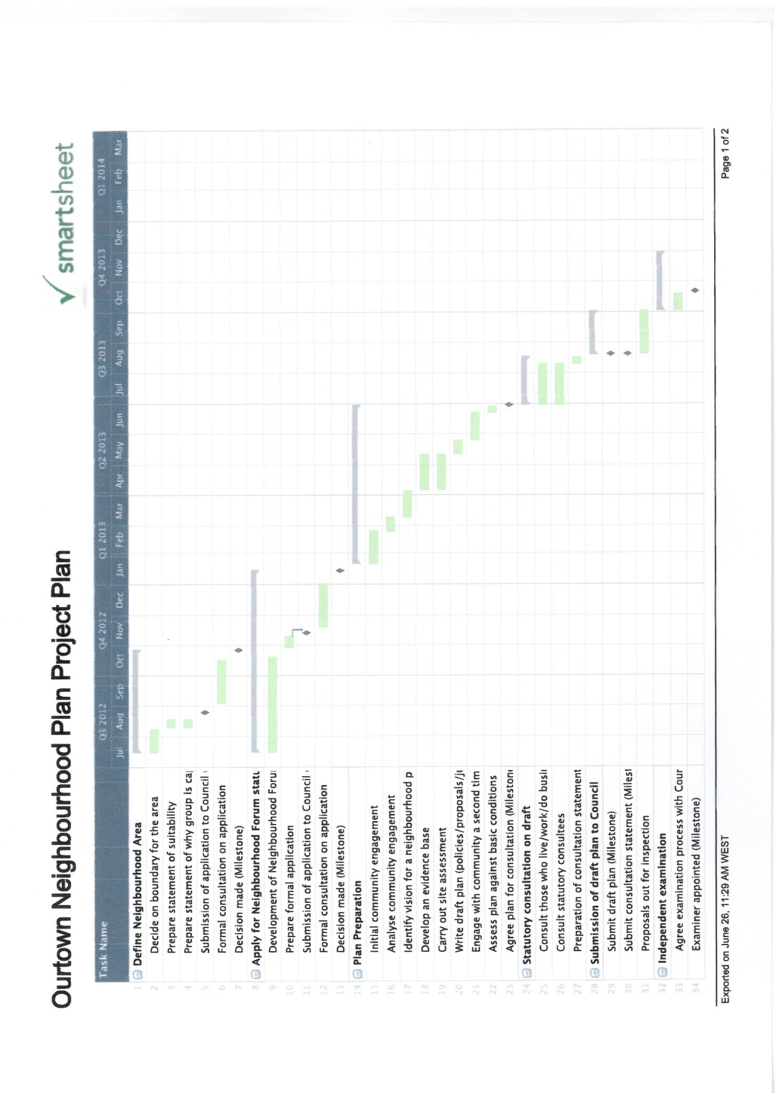

Attachment 3 (Page 2):
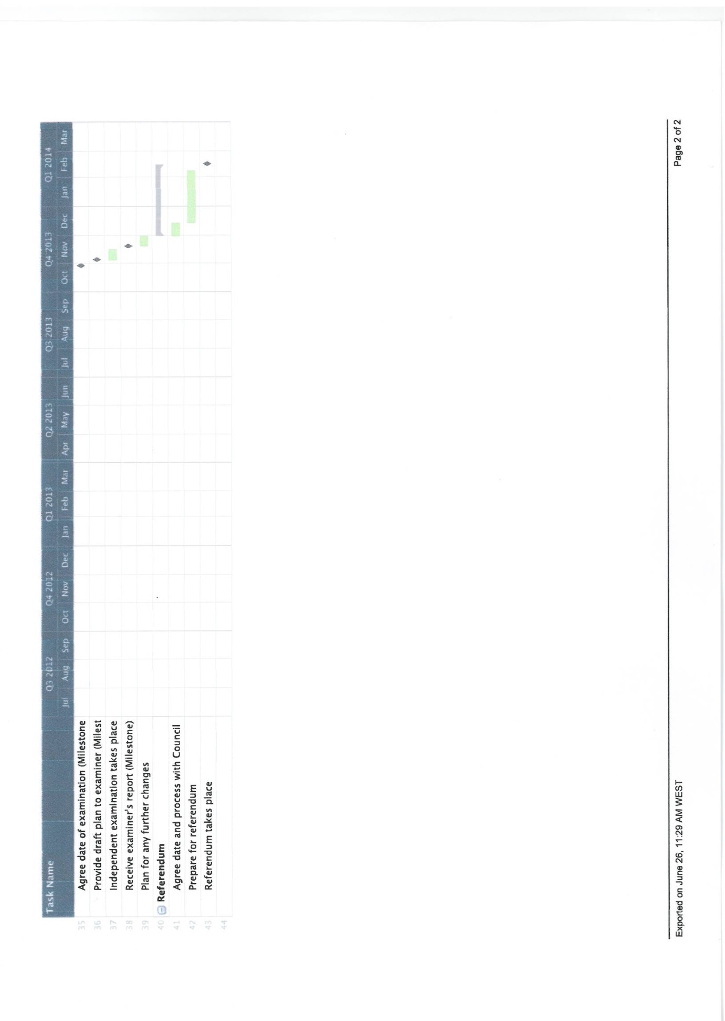

Attachment 4:
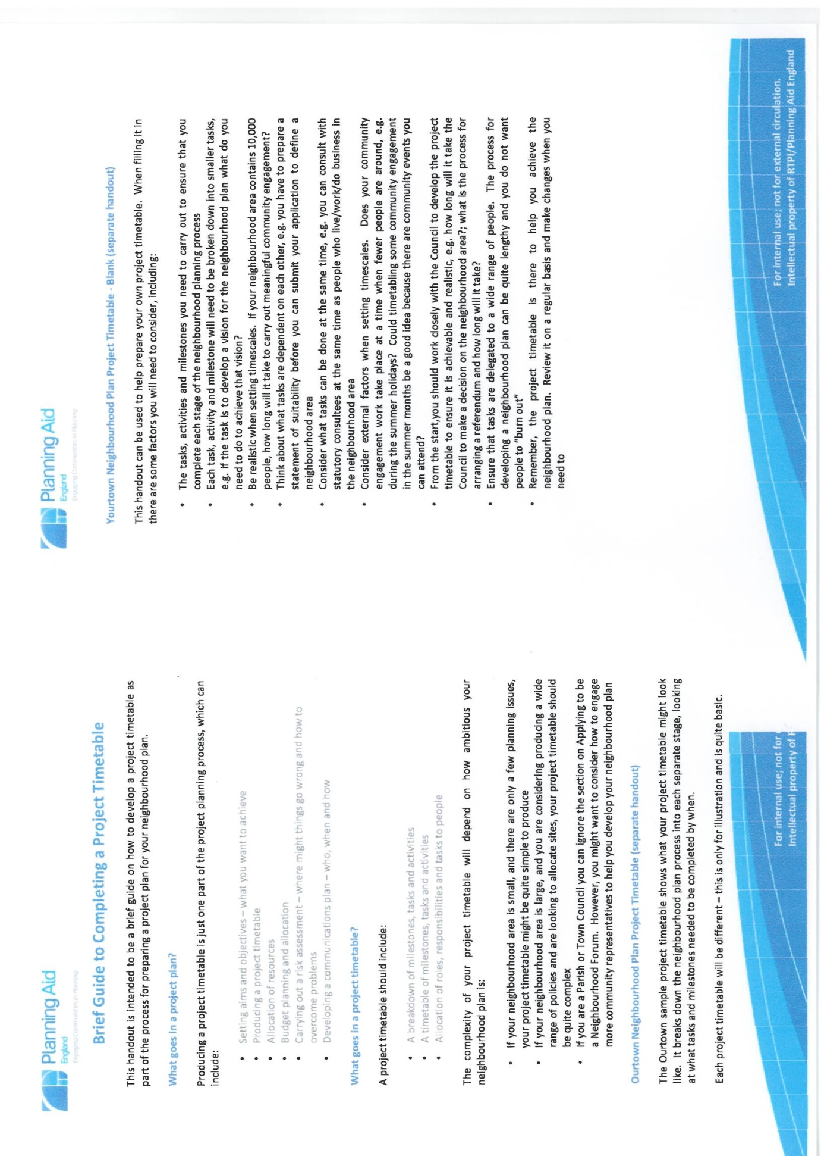

Attachment 5:
